Analytical approaches in human resources – a systematic review

Area: Strategic human resources management and technology

Vinícius Gomes Soaresª - MSc student at University of São Paulo – USP v.gsoares@usp.br – (11) 98440-1636. https://orcid.org/0000-0002-6395-7606

José de Jesús Pérez Alcázarª – Professor at University of São Paulo – USP jperez@usp.br – (11) 96310-8081. https://orcid.org/0000-0003-3389-0401

ªDepartment of Complex Systems Modeling, University of Sao Paulo. Av. Arlindo Bettio, 1000. SP – Brasil;

Mercy Escalante Ludena - IT and Management Consulting. mercylud@gmail.com - Alameda Fernão Cardim, 376/33, SP – Brasil. https://orcid.org/0000-0002-1492-9377

Vinícius Gomes Soares is a complex system modeling MSc student at University of Sao Paulo – USP. He has a bachelor’s degree in electrical engineering from Sao Paulo State University – Unesp (2014). He is experienced in projects and applications of data science in the financial and insurance markets.

José de Jesús Pérez Alcázar has a bachelor’s degree in Systems Engineering and Computation - Universidad de Los Andes (1983), MSc in Computer Science from the Federal University of Minas Gerais (1988) and Ph.D. in Informatics from the Pontifical Catholic University of Rio de Janeiro (1995). He is currently professor at the University of São Paulo. He has experience in Computer Science, focusing on Database and Artificial Intelligence.

Mercy Escalante Ludena has a bachelor’s degree in administration from Univesidad Nacional de Trujillo, MSc in administration from Getulio Vargas Foundation - FGV and Ph.D. in administration from University of Sao Paulo – USP. She is an associate professor and innovation management consultant. Her areas of expertise are strategic management, innovation management, human talent and process management.

Analytical approaches in human resources – a systematic review

Area: Strategic human resources management and technology

Abstract

Surveys related to analytics in the area of human resources (HR) have increased in the last 10 years. They usually suggest frameworks, tools, and concepts. Although there is much useful information, there is still a lack of materials consolidating real case studies or quantitative experiments with HR data. This systematic review analyzes 42 papers with analytical experiments in terms of three different segments of HR: recruitment, talent management, and turnover. The goal is to offer an updated perspective of what is being applied in HR regarding the problems that can be solved with data analysis, the most used techniques, and what could be explored to promote more scientific research on data-oriented projects in HR. Some of the results include talent management as the segment with the most related papers and the use of companies’ internal data as predominant in the studies.

KEYWORDS

HR analytics, People analytics, Strategic human resources management, Talent management, Turnover

1. Introduction
New concepts have been developed in Strategic Human Resource Management (SHRM) over the past three decades. There has been a shift towards a strategic conception that posits workers as “assets” rather than “costs.” These changes have shaped and reconceptualized the area of human resources as a key source of competitive advantage. As such, these assets are to be treated seriously by selecting, training and developing them carefully, and above all, eliciting commitment (Storey, Wright & Ulrich, 2019). Intellectual capital is considered an intangible asset of a company. Among other factors, it is represented by the competence of the employees (Marr, Schiuma & Neely, 2004), SHRM also has a major role in managing this asset. Another responsibility of SHRM is leading the employer brand process, where every employee shapes the organization’s brand, not only the current ones, but also previous employees and future applicants. As social media has the power to multiply any negative or positive effect on the companies’ brand exponentially, this approach is highly strategic (Cascio & Graham, 2016).
The growing competition to obtain the best talents and the changes regarding expectations and opportunities of the labor force are changing the essence of work, as well as necessitating more analytical approaches in the area of human resources (HR) (Guenole, Ferrar & Feinzig, 2017). In the last 20 years, the increase of storage and processing capacity has led to the term “datafication,” which refers to the possibility of converting almost any information from the real world into computer data (Cukier & Mayer-Schoenberger, 2014).
People Analytics (PA) is helping the HR area to be more strategic as decision making is being improved by relying more on evidence and less on intuition. This allows HR to focus on programs that place more value on human management (more people-centered management).
Applying analytics in HR implies internal and external data integration related to human capital, as well as using technology solutions to collect, analyze, and report information to support workforce decisions connected to company results (Marler & Boudreau, 2017). Investing in this practice is a fair way of adding value for a company’s stakeholders. For the effectiveness of the results, simple guidelines focused on decisions should be followed. A good example is the use of database information about turnover, appraisals, and compensations, preferably with a predictive bias instead of a descriptive one (Ingham & Ulrich, 2016).
The aim of this work is to present a systematic review of more recent studies that apply analytics in HR, the most used techniques, the number of publications over the years, and the consolidation of the trending topics and frameworks of the HR area in regard to quantitative analyses. The following section is related to other reviews of analytics in HR. Section 3 presents the methodology used to select studies. Section 4 shows a division of the processes of HR and how the selected studies develop quantitative questions for each process. Section 5 presents a quantitative analysis of the studies regarding the places of publication, information sources used in the studies, goals, and applied techniques. Section 6 presents the conclusions of this research.

2. Related Survey Papers
Periodic systematic reviews are necessary to consolidate the studies of a specific segment, which allows researchers to have access to the state of the art. Two important reviews were published in 2016 (Marler & Boudreau, 2017) and 2018 (Tursunbayeva, Di Lauro, & Pagliari, 2018).
Both the reviews show increasing interest since the early 2000s in the theme of analytics in HR through the number of publications and the searches associated with the issue. Around the first decade of the 2000s, there were few publications per year, but after 2010, the number increased noticeably (Marler & Boudreau, 2017).
Analyzing the searched terms on Google starting from 2004, the term “Work Force
Analytics” was more commonly used, but since 2005, “People Analytics” and “Human Resources Analytics” became more popular, reaching a peak in 2017 Tursunbayeva et al. (2018).
The intent of this work is to compile the main approaches used in HR regarding analytical techniques through the papers published since 2015. The focuses are on what kind of data sources are generally used and the perspectives of HR in which these quantitative analyses are employed. The previous reviews do not focus on these points of view and present a work that is more related to the terms, trends, and concepts of analytics in HR.

3. Research Method
A systematic review may be defined as research aimed at analyzing and interpreting scientific evidence about certain issues through a well-defined methodology (Keele, 2007). According to Keele, the major reasons to undertake such research are to summarize scientific evidence about certain issues in order to understand the pros and cons of some methodology; to identify research gaps suggesting new approaches; and to create a centralized content framework to allow new research based on what has already been done. The results of this paper are adherent to these concepts.
This section describes how systematic review methodology was applied using an analytic framework based on the definition of objectives and research questions, search strategies such as research databases and keywords, inclusion and exclusion criteria, and final selection criteria for a thorough analysis. All these steps will be described in detail below.

3.1. Objectives
This paper dives deeply into the most quantitative and analytical techniques employed and the predictive models that focus on HR. In addition, it maps the number of publications over the last years and the processes that studies have applied. One research question was created to bound the objectives and assure that they would be accomplished:
• RQ. In which segments or process of the human resources area the analytical techniques are being most applied?

3.1.1. Papers Selection Strategy
The search strings were based on some terms used in a previous study (Marler & Boudreau, 2017). Some of them have always been popular, such as PA, and others arose after the 2010s and are related to talent management, such as talent analytics. The main goal was finding studies with real applications of quantitative and computational techniques. The searches were done between January and February
2021.
The strings were “People Analytics”, “Human Resource Analytics”, “HR Analytics”, “Human Capital Analytics”, “Talent Analytics”, “Employee Analytics”, “Employee Performance Prediction”, “Human Resources Machine Learning”, ”Recruitment Analytics”, and “Human Resources Simulation”. The paper selection followed the steps shown in Table 1 and the research databases used in this work were the following: Science Direct, Web of Science, IEEEXplore Digital Library, Direct of Open Access Journals (DOAJ), Taylor & Francis Online, ACM Digital Library, Emerald, SpringerLink
Table 1 - Steps for papers selection to this systematic review
Steps | Description
1 | Raw search of the strings in the research databases
2 | More general selection based on the reading of abstract and conclusion in order to check more directed applications of analytical and computational methods
3 | Exclusion of duplicate papers
4  5 | Selection of published studies after 2015  Final selection of the papers for the thorough analysis

As shown in Table 1, the exclusion criteria were publications from before 2015, those only touching on analytical themes or showing indirect applications, and incomplete or duplicate texts. Figure 1 shows the results of the searches using all the listed strings after the application of steps 1 and 2 in Table 1. The goal is to show an extensive picture of each research database’s content. Thus, steps 3, 4, and 5 were not considered here.
Figure 1: Results of each research database after Steps 1 and 2
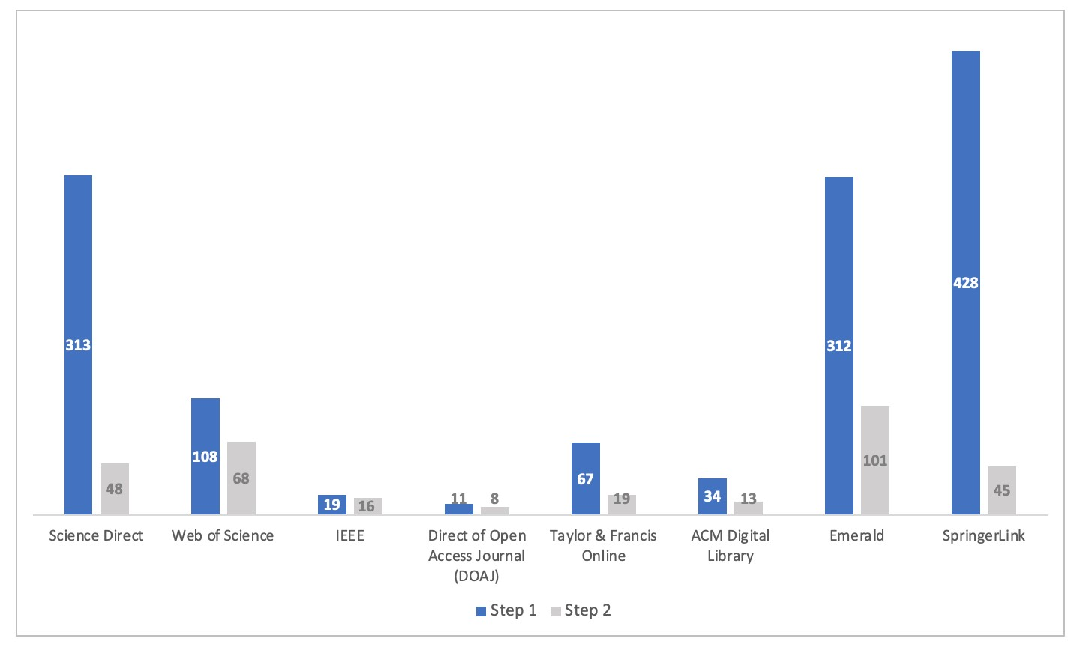
Source: Elaborated by the authors

SpringerLink was the database with the most studies related to analytics focused on HR, followed by ScienceDirect. The lowest number of results was obtained from the DOAJ database. However, the research databases with the most results were the ones with papers on broader and more indirect analytical applications in HR, with more concepts and reviews instead of practical experiments. When evaluating the results after step 2, Emerald and Web of Science were the research databases with the most direct results regarding quantitative approaches or predictive models.
Another measure used to analyze the strings in the research databases is the conversion rate, which shows the ratio of the selected papers in steps 1 and 2. The higher the conversation rate is, the more propensity there is to find a paper with analytical applications in HR. Table 2 shows the results.
Table 2 - Conversion rate of the research databases
Research Database | Conversion Rate
IEEE | 84.2%
Direct of Open Access Journal (DOAJ) | 72.7%
Web of Science | 63.0%
ACM Digital Library | 38.2%
Emerald | 32.4%
Taylor & Francis Online | 28.4%
Science Direct | 15.3%

With this information, it is possible to conclude that if the goal is a wider and extensive study of the analytical methods employed in HR, SpringerLink and ScienceDirect have the greatest number of papers. But if the goal is a more focused and directed study of the analytical experiments in this area, Emerald and Web of Science have the greatest number of publications related to this issue. Lastly, if the intention is to find more directed materials over analytics in HR with less filters, IEEE and DOAJ are more appropriate.
From the evaluation of the searched strings, according to Tursunbayeva Tursunbayeva et al. (2018), the most popular strings until 2018 were “People Analytics” and “HR Analytics”. This work also shows that this trend is apparent nowadays, but the string “HR Analytics” has been seen more often than “People Analytics”, which is different from previous observations. Table 3 shows the results after steps 1 and 2, which present the popularity of each string and the conversion rate. With this information, it is possible to infer which string may have more studies related to analytics in HR.
Table 3 - Search results per string
Strings | Step 1 | Step 2 | Conversion
HR Analytics && Human Resources Analytics | 594 | 120 | 20.2%
People Analytics | 402 | 102 | 25.4%
Talent Analytics | 130 | 47 | 36.2%
Human Capital Analytics | 90 | 29 | 32.2%
Employee Analytics | 31 | 3 | 9.7%
Recruitment Analytics | 28 | 9 | 32.2%
Human Resources Simulation | 7 | 2 | 28.6%
Employee Performance Prediction | 5 | 3 | 60.0%
Human Resources Machine Learning | 5 | 5 | 60.0%

When all duplicate results were excluded in step 3, the number of studies dropped from 318 to 183 (a reduction of 41.2%). The application of step 4 decreased the results to 164 (11.8% less than after step 3). The majority of works were published after 2015 (the reduction after this step was relatively small). The last step, which involved a more rigorous reading of the studies, reduced the results to 42 studies. Thus, 42 studies had more directed applications in the analytical area focused on HR.
The Figure 2 shows the number of scientific publications per year. Although PA and HR analytics became relatively trending topics, the directed statistics and computational applications in this area did not show the same tendency. The drop between the raw search after the selection steps shows that the majority of the works do not effectively apply quantitative techniques or predictive models.

Figure 2: Number of papers over time
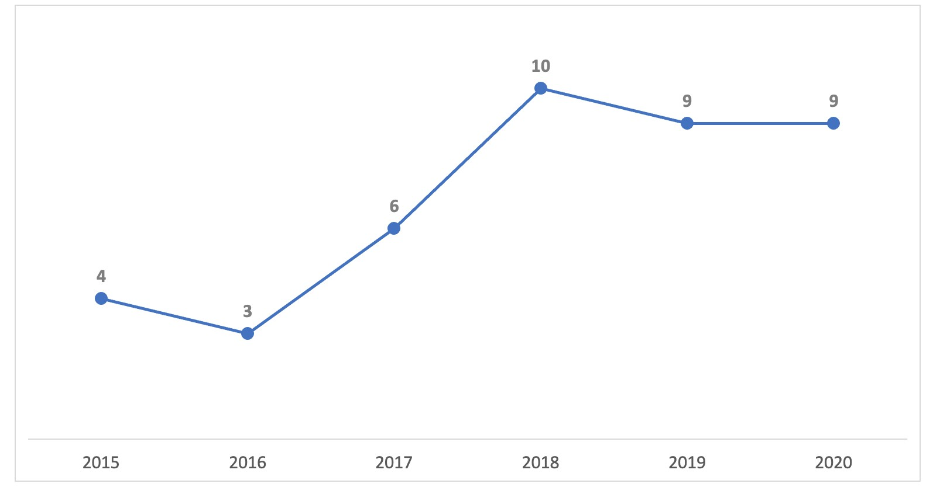
Source: Elaborated by the authors
It is important to mention that research was published in just 2 months in the year 2021, which is the reason why the year is not shown in the graph, but even so, one such work appeared in the final selection totalizing 42 papers. Table 4 shows where those papers were published. If conferences had not been taken into consideration, this review would have had a smaller number of studies (around half). Conference papers are important to the scholarly communication, they are seen as precursors leading to the creation of journal articles (Drott, 1995), and usually have more concise and direct applications.
Table 4 - The main types of publications
Means of Publication | Amount
Book Chapters | 1
Conference Papers | 20
Journal Articles | 21

The Table 5 shows the complete list of the 42 selected studies for this review. All of them apply in some level Analytics approaches in Human Resources.

Table 5 – Selected papers for this review
Item Type | Publication Year | Author | Title | Publication Title | Pages | Volume | Publisher | Conference Name
Conference Paper | 2019 | Alam, Mirza Mohtashim; Mohiuddin, Karishma; Islam, Md. Kabirul; Hassan, Mehedi; Hoque, Md. Arshad-Ul; Allayear, Shaikh Muhammad | A Machine Learning Approach to Analyze and Reduce Features to a Significant Number for Employee’s Turn Over Prediction Model | Intelligent Computing | 142-159 |  | Springer International Publishing
Conference Paper | 2019 | DSouza, Preethi Keerthi | Absolute answerability in the Era of Artificial Intelligence and Machine Learning: A talent management perspective | 2019 International Conference on Digitization (ICD) |  |  |  | 2019 International Conference on Digitization (ICD)
Conference Paper | 2015 | Palshikar, Girish Keshav; Sahu, Kuleshwar; Srivastava, Rajiv | After You, Who? Data Mining for Predicting Replacements | Mining Intelligence and Knowledge Exploration | 543-552 |  | Springer International Publishing
Conference Paper | 2018 | Islam, Md. Kabirul; Alam, Mirza Mohtashim; Islam, Md. Baharul; Mohiuddin, Karishma; Das, Amit Kishor; Kaonain, Md. Shamsul | An Adaptive Feature Dimensionality Reduction Technique Based on Random Forest on Employee Turnover Prediction Model | Advances in Computing and Data Sciences | 269-278 |  | Springer
Book Section | 2019 | Palshikar, Girish Keshav; Srivastava, Rajiv; Pawar, Sachin; Hingmire, Swapnil; Jain, Ankita; Chourasia, Saheb; Shah, Mahek | Analytics-Led Talent Acquisition for Improving Efficiency and Effectiveness | Advances in Analytics and Applications | 141-160 |  | Springer
Conference Paper | 2018 | Sela, Alon; Ben-Gal, Hila Chalutz | Big Data Analysis of Employee Turnover in Global Media Companies, Google, Facebook and Others | 2018 IEEE International Conference on the Science of Electrical Engineering in Israel (ICSEE) |  |  |  | 2018 IEEE International Conference on the Science of Electrical Engineering in Israel (ICSEE)
Journal Article | 2018 | Lopes, Susana Almeida; Duarte, Maria Eduarda; Almeida Lopes, João | Can artificial neural networks predict lawyers’ performance rankings? | International Journal of Productivity and Performance Management | 1940-1958 | 67
Journal Article | 2017 | N’Cho, Julie | Contribution of talent analytics in change management within project management organizations. The case of the French aerospace sector | Procedia Computer Science | 625-629 | 121
Journal Article | 2019 | Xu, Huang; Yu, Zhiwen; Yang, Jingyuan; Xiong, Hui; Zhu, Hengshu | Dynamic Talent Flow Analysis with Deep Sequence Prediction Modeling | IEEE Transactions on Knowledge and Data Engineering | 1926-1939 | 31
Journal Article | 2018 | Khodakarami, Nima; Dirani, Khalil; Rezaei, Fatemeh | Employee engagement: finding a generally accepted measurement scale | Industrial and Commercial Training | 305-311 | 50
Journal Article | 2020 | Pessach, Dana; Singer, Gonen; Avrahami, Dan; Chalutz Ben-Gal, Hila; Shmueli, Erez; Ben-Gal, Irad | Employees recruitment: A prescriptive analytics approach via machine learning and mathematical programming | Decision Support Systems |  | 134
Journal Article | 2020 | Lin, Hao; Zhu, Hengshu; Wu, Junjie; Zuo, Yuan; Zhu, Chen; Xiong, Hui | Enhancing Employer Brand Evaluation with Collaborative Topic Regression Models | ACM Transactions on Information Systems | 32:1–32:33 | 38
Conference Paper | 2020 | Tang, Avery; Lu, Timothy; Lynch, Zachary; Schaer, Oliver; Adams, Stephen | Enhancing Promotion Decisions using Classification and Network-based Methods | 2020 Systems and Information Engineering Design Symposium (SIEDS) |  |  |  | 2020 Systems and Information Engineering Design Symposium (SIEDS)
Conference Paper | 2017 | Sisodia, Dilip Singh; Vishwakarma, Somdutta; Pujahari, Abinash | Evaluation of machine learning models for employee churn prediction | 2017 International Conference on Inventive Computing and Informatics (ICICI) | 1016-1020 |  |  | 2017 International Conference on Inventive Computing and Informatics (ICICI)
Journal Article | 2018 | van der Laken, Paul; Bakk, Zsuzsa; Giagkoulas, Vasileios; van Leeuwen, Linda; Bongenaar, Esther | Expanding the methodological toolbox of HRM researchers: The added value of latent bathtub models and optimal matching analysis: Expanding the methodological toolbox of HRM researchers: The added value of latent bathtub models and optimal matching analysis | Human Resource Management | 751-760 | 57
Conference Paper | 2020 | Peisl, Thomas; Edlmann, Raphael | Exploring Technology Acceptance and Planned Behaviour by the Adoption of Predictive HR Analytics During Recruitment | Systems, Software and Services Process Improvement | 177-190 |  | Springer International Publishing
Journal Article | 2020 | Saling, Kristin C.; Do, Michael D. | Leveraging People Analytics for an Adaptive Complex Talent Management System | Procedia Computer Science | 105-111 | 168
Conference Paper | 2018 | Papoutoglou, Maria; Kapitsaki, Georgia M.; Mittas, Nikolaos | Linking Personality Traits and Interpersonal Skills to Gamification Awards | 2018 44th Euromicro Conference on Software Engineering and Advanced Applications (SEAA) | 214-221 |  | IEEE | 2018 44th Euromicro Conference on Software Engineering and Advanced Applications (SEAA)
Conference Paper | 2019 | de Oliveira, Evandro Lopes | Machine Learning Techniques Applied to Predict the Performance of Contact Centers Operators | 2019 14th Iberian Conference on Information Systems and Technologies (CISTI) |  |  |  | 2019 14th Iberian Conference on Information Systems and Technologies (CISTI)
Conference Paper | 2017 | Papoutsoglou, Maria; Mittas, Nikolaos; Angelis, Lefteris | Mining People Analytics from StackOverflow Job Advertisements | 2017 43rd Euromicro Conference on Software Engineering and Advanced Applications (SEAA) | 108-115 |  | IEEE | 2017 43rd Euromicro Conference on Software Engineering and Advanced Applications (SEAA)
Conference Paper | 2017 | Cahyani, Anggita Dian; Budiharto, Widodo | Modeling Intelligent Human Resources Systems (IRHS) using Big Data and Support Vector Machine (SVM) | Proceedings of the 9th International Conference on Machine Learning and Computing | 137–140 |  | Association for Computing Machinery
Journal Article | 2018 | Nandialath, Anup Menon; David, Emily; Das, Diya; Mohan, Ramesh | Modeling the determinants of turnover intentions: a Bayesian approach | Evidence-based HRM: a Global Forum for Empirical Scholarship |  | 6
Conference Paper | 2015 | Wei, Dennis; Varshney, Kush R.; Wagman, Marcy | Optigrow: People Analytics for Job Transfers | 2015 IEEE International Congress on Big Data | 535-542 |  | IEEE | 2015 IEEE International Congress on Big Data (BigData Congress)
Journal Article | 2017 | Mohapatra, Mamta; Sahu, Priyanka | Optimizing the Recruitment Funnel in an ITES Company: An Analytics Approach | Procedia Computer Science | 706-714 | 122
Conference Paper | 2017 | Singer, Leif; Storey, Margaret-Anne; Figueira Filho, Fernando; Zagalsky, Alexey; German, Daniel M. | People Analytics in Software Development | Grand Timely Topics in Software Engineering | 124-153 |  | Springer International Publishing
Journal Article | 2019 | Necula, Sabina-Cristiana; Strîmbei, Cătălin | People Analytics of Semantic Web Human Resource Résumés for Sustainable Talent Acquisition | Sustainability |  | 11
Journal Article | 2018 | Rombaut, Evy; Guerry, Marie-Anne | Predicting voluntary turnover through human resources database analysis | Management Research Review | 96-112 | 41
Conference Paper | 2019 | Karande, Shubham; Shyamala, L. | Prediction of Employee Turnover Using Ensemble Learning | Ambient Communications and Computer Systems | 319-327 |  | Springer
Journal Article | 2015 | Agrawal, Soni | Predictors of employee engagement: a public sector unit experience | Strategic HR Review |  | 14
Journal Article | 2020 | Kakulapati, V.; Chaitanya, Kalluri Krishna; Chaitanya, Kolli Vamsi Guru; Akshay, Ponugoti | Predictive analytics of HR - A machine learning approach | Journal of Statistics and Management Systems
Journal Article | 2016 | Pape, Tom | Prioritising data items for business analytics: Framework and application to human resources | European Journal of Operational Research | 687-698 | 252
Conference Paper | 2016 | Palshikar, Girish Keshav; Pawar, Sachin; Ramrakhiyani, Nitin | Role Models: Mining Role Transitions Data in IT Project Management | 2016 IEEE International Conference on Data Science and Advanced Analytics (DSAA) | 508-517 |  |  | 2016 IEEE International Conference on Data Science and Advanced Analytics (DSAA)
Conference Paper | 2020 | Aswale, Neerja; Mukul, Kavya | Role of Data Analytics in Human Resource Management for Prediction of Attrition Using Job Satisfaction | Data Management, Analytics and Innovation | 57-67 |  | Springer
Journal Article | 2018 | Somers, Mark John; Birnbaum, Dee; Casal, Jose | Supervisor support, control over work methods and employee well-being: new insights into nonlinearity from artificial neural networks | The International Journal of Human Resource Management
Conference Paper | 2016 | Xu, Huang; Yu, Zhiwen; Yang, Jingyuan; Xiong, Hui; Zhu, Hengshu | Talent Circle Detection in Job Transition Networks | Proceedings of the 22nd ACM SIGKDD International Conference on Knowledge Discovery and Data Mining | 655–664 |  | Association for Computing Machinery
Journal Article | 2020 | Rombaut, Evy; Guerry, Marie-Anne | The effectiveness of employee retention through an uplift modeling approach | International Journal of Manpower
Conference Paper | 2019 | Sun, Ying; Zhuang, Fuzhen; Zhu, Hengshu; Song, Xin; He, Qing; Xiong, Hui | The Impact of Person-Organization Fit on Talent Management: A Structure-Aware Convolutional Neural Network Approach | Proceedings of the 25th ACM SIGKDD International Conference on Knowledge Discovery & Data Mining | 1625–1633 |  | Association for Computing Machinery
Journal Article | 2015 | Altındağ, Erkut; Kösedağı, Yeliz | The Relationship Between Emotional Intelligence of Managers, Innovative Corporate Culture and Employee Performance | Procedia - Social and Behavioral Sciences | 270-282 | 210
Conference Paper | 2021 | Jain, Diksha; Makkar, Sandhya; Jindal, Lokesh; Gupta, Mukta | Uncovering Employee Job Satisfaction Using Machine Learning: A Case Study of Om Logistics Ltd | International Conference on Innovative Computing and Communications | 365-376 |  | Springer
Journal Article | 2020 | Newman, David T.; Fast, Nathanael J.; Harmon, Derek J. | When eliminating bias isn’t fair: Algorithmic reductionism and procedural justice in human resource decisions | Organizational Behavior and Human Decision Processes | 149-167 | 160
Journal Article | 2019 | Beutell, Nicholas J.; Alstete, Jeffrey W.; Schneer, Joy A.; Hutt, Camille | A look at the dynamics of personal growth and self-employment exit | International Journal of Entrepreneurial Behavior & Research | 1452-1470 | 25
Journal Article | 2018 | Gelbard, Roy; Ramon-Gonen, Roni; Carmeli, Abraham; Bittmann, Ran M.; Talyansky, Roman | Sentiment analysis in organizational work: Towards an ontology of people analytics | Expert Systems |  | 35

4. Analytics in HR
Based on the selected papers, this section compiles what has been employed in terms of analytics, techniques, and parts of the HR chain that were the focus of the studies.

4.1. Processes and Areas of HR
The HR area has strategic roles linked to processes, people, and culture management (Thite, Budhwar, & Wilkinson, 2014). Thus, it is natural to have divided areas and processes so that HR can accomplish its role more efficiently. According to Lawler (Lawler, Boudreau, Mohrman, Mark, & Osganian, 2006) the HR area can be divided into 8 activities: design and organization development, compensation and benefits, legal and regulatory, employee development, recruitment and selection, metrics, HR information systems, and unions, which each have specific subactivities. After the analysis of the selected papers, it was noticed that some segments are more likely to apply analytics because their activities and processes have wider space to optimize proceedings, they are more measurable, or they deal with more strategic factors related to a business’s profit.
The division suggested in this paper is based on two major influences. The first one is based on Lawler, Lawler et al. (2006), where the most similar divisions are activities of employee development, recruitment and selection, and metrics. The second one is the selected papers of this review, where the recurrence of its applications were taken into consideration.

4.1.1. Recruitment and Selection
Recruitment and selection are one of the most strategic and challenging processes, mostly because it is more attached to business revenues and margins than other HR processes (Pessach, Singer, Avrahami, Ben-Gal, Shmueli, & Ben-Gal, 2020). Applying analytics in recruitment and selection is about tracking, measuring, and collecting, candidates’ data in order to improve the hiring process. More specifically, it is about jointly analyzing performance data, work requirements, and candidate profiles (Mohapatra & Sahu, 2017). As recruitment involves external data from outside the company, there are more opportunities linked with data mining.
This was observed in two selected papers. The first one (Palshikar, Srivastava, Pawar, Hingmire, Jain, Chourasia, & Shah, 2019), presents a way to have more efficiency in the recruitment process through text mining applications in real cases of a big IT company. That study used a CV information extracting algorithm called RINX. The second one, (Papoutsoglou, Mittas, & Angelis, 2017), aimed to extract relevant information from job ads on the web (specifically the Stack Overflow website). The goal was to show which candidates have the skills most wanted by recruiters and to show companies the trends related to the professional market.
Both of them used certain techniques that bypass one of the greatest problems in applying analytics in HR: the small quantity of significant data.
Even with the difficult point in obtaining significant volumes of data, one study (Necula & Strîmbei, 2019), sought to create a framework to collect and prepare data from CVs with 213 documents using techniques to predict specific skills, such as a support vector machine (SVM), (Lorena & de Carvalho, 2007), K-nearest neighbor (K-NN) (Dhanabal & Chandramathi, 2011), decision trees (Kothari & Dong, 2001), naive bayes (Rish, 2001) and random forest (Breiman, 2001) methods. Hence, they could predict the adherence of candidates to job opportunities before hiring them. Other papers (Peisl & Edlmann, 2020) and (Mohapatra & Sahu, 2017) focused more on showing frameworks to obtain more efficiency in the recruitment process as a whole and showed a descriptive analysis.

4.1.2. Talent Management
The talent management area includes all activities related to the identification, attraction, development, and retention of people with expected or proven performance that is above average. Such people represent around 20% of a company workforce and contribute significantly to the thriving of the organization, especially because they have unique skills that are hard to find (N’Cho, 2017), as cited in (Meyers & Van Woerkom, 2014); (Malik & Singh, 2014); (Dries, Van Acker, & Verbruggen, 2012); (Gallardo-Gallardo, Dries, & González-Cruz, 2013).
One article (Khodakarami, Dirani, & Rezaei, 2018) explores engagement and uses multi-criteria decision making to present methods that may be efficient for managers who aim to rate their employees’ engagement levels. Another publication (Agrawal, 2015) explores the question through a questionnaire with 102 people in a company. The focus was on the importance of the engagement in the work, was differentiated from other ways of obtaining professional satisfaction. To do this, the study used questionnaire data and descriptive statistics with multivariate regression.
Regarding human factors in professional performance, another study (Gelbard, Ramon‐Gonen, Carmeli, Bittmann, & Talyansky, 2018) applied text mining and a naive Bayes classifier to a public database with more than 600,000 e-mails from 158 employees. The aim was to use sentiment analysis to create key performance indicators (KPIs) for soft skills, such as creativity, innovation, efficiency, and engagement. Another study (Altındağ & Kösedağı, 2015) adopted questionnaires to establish the relationship between emotional intelligence in leadership, innovation culture, and employee performance in a company.
By extracting data from LinkedIn, one study (Xu, Yu, Yang, Xiong, & Zhu, 2016) looked at talent networks it used graphs to create a network connection between talents and companies. The graph vertices show the adherence of an employee and the company.
There are two examples of publications with emphasis on prediction and performance appraisals of employees. One study (Lopes, Duarte, & Lopes, 2018) used artificial neural networks (ANNs) as an alternative to traditional appraisals methods in an advocacy office. The networks were applied to information like dedicated hours to customers, role level, and time working in the company. The other study (Tang, Lu, Lynch, Schaer, & Adams, 2020) used not only internal company data about the employees, such as salary, role level, and education, but also demographic data related to their addresses. The goal was to find professionals with more potential to be promoted by applying logistic regression, SVM, and random forest techniques. In this context, there are other applications of analytics in talent management involving quantitative techniques to maximize the chance of finding the best possible candidate for a specific position inside the company before searching in the market. In one such study (Palshikar, Sahu, & Srivastava, 2015) 1092 pairs of employees of an IT company were examined using supervised and unsupervised
algorithms.

4.1.3. Turnover
In practical terms, turnover can be defined as the ratio between the number of employees who have left the company and the total amount of employees in the company during a specific time. Identifying the main reasons for turnover is important because a high rate may damage a company’s brand and make it more difficult to attract talents (Islam, Alam, Islam, Mohiuddin, Das, & Kaonain, 2018).
The articles (Alam, Mohiuddin, Islam, Hassan, Hoque, & Allayear, 2018) and (Karande, Shyamala, Hu, Tiwari, Mishra, & Trivedi, 2019) are examples where the goal is to understand the main reasons for employee turnover using techniques such as decision trees, logistic regression, and other algorithms. When the focus is more on the reasons and not in the prediction itself, the techniques have a better fit if the importance of the variables shown. One study Alam et al. (2018) outlines the data volume problem using a public HR database from Kaggle with 15,000 registers of employees, of which 3,572 have left a company.
There are studies that look more at the development of techniques to predict employee turnover, where accuracy is more important Islam et al. (2018) and (Sisodia, Vishwakarma, & Pujahari, 2017). These studies use algorithms such as random forest, KNN, SVM, and naive Bayes in order to find the best fit for the problem. As there is a public-domain database with 15,000 registers with the features cited above, the paths to studying applications in turnover rate are more open. This total amount of records allows for more possibilities regarding the available techniques.
Of the analyzed studies on employee turnover, some use the Kaggle’s mentioned database Alam et al. (2018), Islam et al. (2018) and Sisodia et al. (2017), while others also use big databases (Cahyani & Budiharto, 2017) and (Rombaut & Guerry, 2018), one with 50,000 records and another with 13,485. However, other studies (Dsouza, 2019), (Nandialath, David, Das, & Mohan, 2018), (Aswale & Mukul, 2020), (Rombaut & Guerry, 2020) and (Jain, Makkar, Jindal, & Gupta, 2021) use databases with fewer than 2,000 records from internal questionnaires applied in the companies. The unplanned exit of employees definitely needs to be studied and usually has a high impact on costs, which may reach millions of dollars lost in recruitment, training, and productivity drops. The reasons for leaving a current job are related to many complex factors, such as emotional, psychological, personal, and financial questions, in addition to the labor market Nandialath et al. (2018).

5. Quantitative Analysis of the Selected Papers
As mentioned in section 3, the present work included 42 studies with some kind of application, practical experiment, or thorough description of quantitative analysis in HR. Figure 3 shows the percentage of each segment in the selected sample.
Figure 3: Percentage of each segment in the selected papers sample
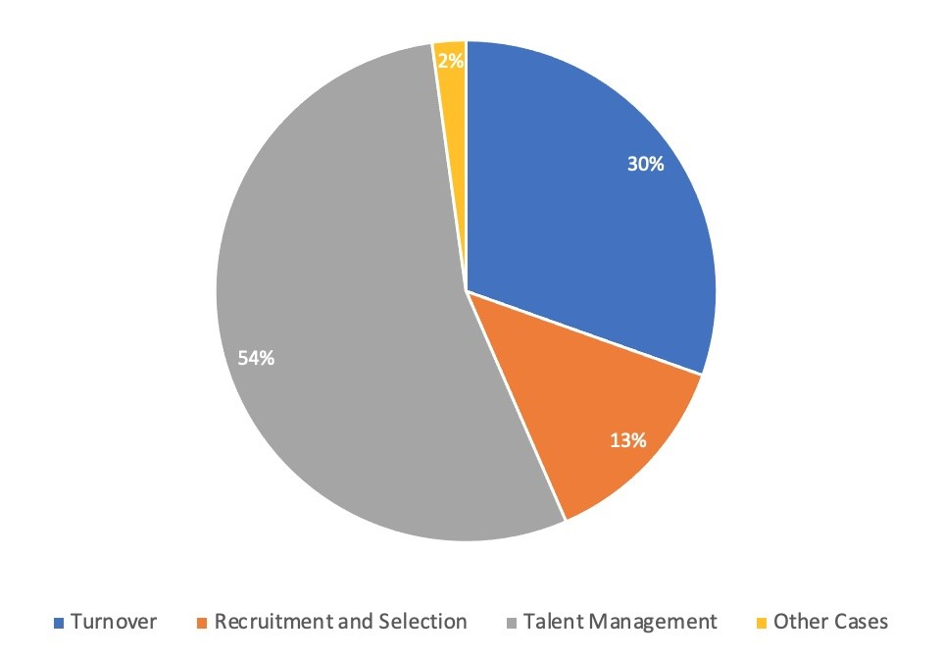
Source: Elaborated by the authors
The themes examined by each study were interpreted while considering the best fit of some division presented in section 4. In some cases, the studies approached more than one division, so they were included more than one time in the table. The line “Other Cases” covers one study that shows a way of analyzing companies’ reviews made by employees on specific platforms (Lin et al, 2020).
It was seen that 54% of the selected studies focused on talent management. This is not a surprise because the fast changes in technologies and market require a well prepared and adapted staff to carry out the company’s strategies. Furthermore, talent management may include topics like engagement, internal employee replacement, and even key candidate recruitment. It is important to mention that the difference among the divisions might be tenuous, and other interpretations may occur.

6. Conclusions
This systematic review has shown that in general, the selected studies apply more than one analytical technique in their approaches. However, it is possible to highlight the following algorithms: random forest, which was used in 11 of 42 studies, SVM, which was used in 10 studies, and regression models, which were used in 8 studies. One of the greatest obstacles in applying analytical techniques is the data volume. Currently, companies with their own databases of employees’ KPIs are still not widespread. This is especially demonstrated by the fact that 7 studies used public domain databases in order to evaluate the application of their analyses. When the goal was doing a real case study, the studies used internal research, which generally supplies fewer records and ends up limiting the possibilities of applications.
Of the 3 selected processes of HR, talent management was the most studied. This mainly occurs because this process is more general and allows for studies of employee performance, internal staff replacement, and engagement. But recruitment and turnover showed more versatility regarding the group of techniques applied. The turnover process has good public-domain databases that offer the possibility of testing and improving algorithms before applying them and doing case studies. Regarding the recruitment and selection process, more studies looked at the use of external data, such as CVs, professional social networks, and job advertisements websites. Regarding PA, few studies used quantitative techniques, but there has been an increasing trend in the last years.
Human factors are directly associated with company success and are reflected through the enhancement of employee efficiency, increasing revenue, and reductions in hiring costs, resignations, and absences. By using analytical techniques that are frequently applied in the marketing and financial market, we can open different paths through which companies can obtain more competitive advantages in competitive and volatile markets. Public databases are important for providing an incentive for companies to invest more in data storage systems for HR, which would allow for the adoption of new approaches in real study cases.
References

Agrawal, S. (2015). Predictors of employee engagement: A public sector unit experience. Strategic HR Review.
Alam, M. M., Mohiuddin, K., Islam, M. K., Hassan, M., Hoque, M. A. U., & Allayear, S. M. (2018, July). A machine learning approach to analyze and reduce features to a significant number for employee’s turn over prediction model. In Science and Information Conference (pp. 142-159). Springer, Cham.
Altındağ, E., & Kösedağı, Y. (2015). The relationship between emotional intelligence of managers, innovative corporate culture and employee performance. Procedia-Social and Behavioral Sciences, 210, 270-282.
Aswale, N., & Mukul, K. (2020). Role of data analytics in human resource management for prediction of attrition using job satisfaction. In Data Management, Analytics and Innovation (pp. 57-67). Springer, Singapore.
Beutell, N. J., Alstete, J. W., Schneer, J. A., & Hutt, C. (2019). A look at the dynamics of personal growth and self-employment exit. International Journal of Entrepreneurial Behavior & Research.
Breiman, L. (2001). Random forests. Machine learning, 45(1), 5-32.
Cahyani, A. D., & Budiharto, W. (2017, February). Modeling intelligent human resources systems (irhs) using big data and support vector machine (svm). In Proceedings of the 9th International Conference on Machine Learning and Computing (pp. 137-140).
Cascio, W. F., & Graham, B. Z. (2016). New strategic role for HR: Leading the employer-branding process. Organization Management Journal, 13(4), 182-192.
Cukier, K., & Mayer-Schoenberger, V. (2014). The rise of big data: How it’s changing the way we think about the world (pp. 20-32). Princeton University Press.
de Oliveira, E. L. (2019, June). Machine Learning Techniques Applied to Predict the Performance of Contact Centers Operators. In 2019 14th Iberian Conference on Information Systems and Technologies (CISTI) (pp. 1-4). IEEE.
Dhanabal, S., & Chandramathi, S. J. I. J. C. A. (2011). A review of various k-nearest neighbor query processing techniques. International Journal of Computer Applications, 31(7), 14-22.
Dries, N., Van Acker, F., & Verbruggen, M. (2012). How ‘boundaryless’ are the careers of high potentials, key experts and average performers?. Journal of Vocational Behavior, 81(2), 271-279.
DSouza, P. K. (2019, November). Absolute answerability in the Era of Artificial Intelligence and Machine Learning: A talent management perspective. In 2019 International Conference on Digitization (ICD) (pp. 8-13). IEEE.
Drott, M. C. (1995). Reexamining the role of conference papers in scholarly communication. Journal of the American Society for Information Science, 46(4), 299-305.
Gallardo-Gallardo, E., Dries, N., & González-Cruz, T. F. (2013). What is the meaning of ‘talent’in the world of work?. Human Resource Management Review, 23(4), 290-300.
Gelbard, R., Ramon‐Gonen, R., Carmeli, A., Bittmann, R. M., & Talyansky, R. (2018). Sentiment analysis in organizational work: Towards an ontology of people analytics. Expert Systems, 35(5), e12289.
Guenole, N., Ferrar, J., & Feinzig, S. (2017). The power of people: Learn how successful organizations use workforce analytics to improve business performance. FT Press.
Ingham, J., & Ulrich, D. (2016). Building better HR departments. Strategic HR Review.
Islam, M. K., Alam, M. M., Islam, M. B., Mohiuddin, K., Das, A. K., & Kaonain, M. S. (2018, April). An adaptive feature dimensionality reduction technique based on random forest on employee turnover prediction model. In International Conference on Advances in Computing and Data Sciences (pp. 269-278). Springer, Singapore.
Jain, D., Makkar, S., Jindal, L., & Gupta, M. (2021). Uncovering Employee Job Satisfaction Using Machine Learning: A Case Study of Om Logistics Ltd. In International Conference on Innovative Computing and Communications (pp. 365-376). Springer, Singapore.
Kakulapati, V., Chaitanya, K. K., Chaitanya, K. V. G., & Akshay, P. (2020). Predictive analytics of HR-A machine learning approach. Journal of Statistics and Management Systems, 23(6), 959-969.
Karande, S., Shyamala, L., Hu, Y. C., Tiwari, S., Mishra, K. K., & Trivedi, M. C. (2019). Prediction of employee turnover using ensemble learning. In Ambient Communications and Computer Systems (Vol. 904, pp. 319-327). Springer.
Keele, S. (2007). Guidelines for performing systematic literature reviews in software engineering (Vol. 5). Technical report, Ver. 2.3 EBSE Technical Report. EBSE.
Khodakarami, N., Dirani, K., & Rezaei, F. (2018). Employee engagement: finding a generally accepted measurement scale. Industrial and Commercial Training.
Kothari, R., & Dong, M. I. N. G. (2001). Decision trees for classification: A review and some new results. Pattern recognition: from classical to modern approaches, 169-184.
Lawler, E. E., Boudreau, J. W., Mohrman, S. A., Mark, A. Y., & Osganian, N. (2006). Achieving strategic excellence: An assessment of human resource organizations. Stanford University Press.
Lin, H., Zhu, H., Wu, J., Zuo, Y., Zhu, C., & Xiong, H. (2020). Enhancing employer brand evaluation with collaborative topic regression models. ACM Transactions on Information Systems (TOIS), 38(4), 1-33.
Lopes, S. A., Duarte, M. E., & Lopes, J. A. (2018). Can artificial neural networks predict lawyers’ performance rankings?. International Journal of Productivity and Performance Management.
Lorena, A. C., & de Carvalho, A. C. (2007). Uma introdução às support vector machines. Revista de Informática Teórica e Aplicada, 14(2), 43-67.
Malik, A. R., & Singh, P. (2014). ‘High potential’programs: Let's hear it for ‘B’players. Human Resource Management Review, 24(4), 330-346.
Marler, J. H., & Boudreau, J. W. (2017). An evidence-based review of HR Analytics. The International Journal of Human Resource Management, 28(1), 3-26.
Marr, B., Schiuma, G., & Neely, A. (2004). Intellectual capital–defining key performance indicators for organizational knowledge assets. Business Process Management Journal.
Meyers, M. C., & Van Woerkom, M. (2014). The influence of underlying philosophies on talent management: Theory, implications for practice, and research agenda. Journal of World Business, 49(2), 192-203.
Mohapatra, M., & Sahu, P. (2017). Optimizing the recruitment funnel in an ITES company: An analytics approach. Procedia computer science, 122, 706-714.
Nandialath, A. M., David, E., Das, D., & Mohan, R. (2018, April). Modeling the determinants of turnover intentions: a Bayesian approach. In Evidence-based HRM: a Global Forum for Empirical Scholarship. Emerald Publishing Limited.
N’Cho, J. (2017). Contribution of talent analytics in change management within project management organizations The case of the French aerospace sector. Procedia computer science, 121, 625-629.
Necula, S. C., & Strîmbei, C. (2019). People analytics of semantic web human resource résumés for sustainable talent acquisition. Sustainability, 11(13), 3520.
Newman, D. T., Fast, N. J., & Harmon, D. J. (2020). When eliminating bias isn’t fair: Algorithmic reductionism and procedural justice in human resource decisions. Organizational Behavior and Human Decision Processes, 160, 149-167.
Pape, T. (2016). Prioritising data items for business analytics: Framework and application to human resources. European Journal of Operational Research, 252(2), 687-698.
Palshikar, G. K., Srivastava, R., Pawar, S., Hingmire, S., Jain, A., Chourasia, S., & Shah, M. (2019). Analytics-led talent acquisition for improving efficiency and effectiveness. In Advances in Analytics and Applications (pp. 141-160). Springer, Singapore.
Palshikar, G. K., Sahu, K., & Srivastava, R. (2015, December). After You, Who? Data Mining for Predicting Replacements. In International Conference on Mining Intelligence and Knowledge Exploration (pp. 543-552). Springer, Cham.
Palshikar, G. K., Pawar, S., & Ramrakhiyani, N. (2016, October). Role models: Mining role transitions data in IT project management. In 2016 IEEE International Conference on Data Science and Advanced Analytics (DSAA) (pp. 508-517). IEEE.
Papoutoglou, M., Kapitsaki, G. M., & Mittas, N. (2018, August). Linking personality traits and interpersonal skills to gamification awards. In 2018 44th Euromicro Conference on Software Engineering and Advanced Applications (SEAA) (pp. 214-221). IEEE.
Papoutsoglou, M., Mittas, N., & Angelis, L. (2017, August). Mining people analytics from stackoverflow job advertisements. In 2017 43rd Euromicro Conference on Software Engineering and Advanced Applications (SEAA) (pp. 108-115). IEEE.
Peisl, T., & Edlmann, R. (2020, September). Exploring Technology Acceptance and Planned Behaviour by the Adoption of Predictive HR Analytics During Recruitment. In European Conference on Software Process Improvement (pp. 177-190). Springer, Cham.
Pessach, D., Singer, G., Avrahami, D., Ben-Gal, H. C., Shmueli, E., & Ben-Gal, I. (2020). Employees recruitment: A prescriptive analytics approach via machine learning and mathematical programming. Decision Support Systems, 134, 113290.
Rish, I. (2001, August). An empirical study of the naive Bayes classifier. In IJCAI 2001 workshop on empirical methods in artificial intelligence (Vol. 3, No. 22, pp. 41-46).
Rombaut, E., & Guerry, M. A. (2018). Predicting voluntary turnover through human resources database analysis. Management Research Review.
Rombaut, E., & Guerry, M. A. (2020). The effectiveness of employee retention through an uplift modeling approach. International Journal of Manpower.
Saling, K. C., & Do, M. D. (2020). Leveraging People Analytics for an Adaptive Complex Talent Management System. Procedia Computer Science, 168, 105-111.
Sela, A., & Ben-Gal, H. C. (2018, December). Big data analysis of employee turnover in global media companies, google, facebook and others. In 2018 IEEE International Conference on the Science of Electrical Engineering in Israel (ICSEE) (pp. 1-5). IEEE.
Singer, L., Storey, M. A., Figueira Filho, F., Zagalsky, A., & German, D. M. (2015, August). People analytics in software development. In International Summer School on Generative and Transformational Techniques in Software Engineering (pp. 124-153). Springer, Cham.
Sisodia, D. S., Vishwakarma, S., & Pujahari, A. (2017, November). Evaluation of machine learning models for employee churn prediction. In 2017 International Conference on Inventive Computing and Informatics (ICICI) (pp. 1016-1020). IEEE.
Somers, M. J., Birnbaum, D., & Casal, J. (2021). Supervisor support, control over work methods and employee well-being: New insights into nonlinearity from artificial neural networks. The International Journal of Human Resource Management, 32(7), 1620-1642.
Storey, J., Wright, P. M., & Ulrich, D. (2019). Strategic human resource management: A research overview. Routledge.
Sun, Y., Zhuang, F., Zhu, H., Song, X., He, Q., & Xiong, H. (2019, July). The impact of person-organization fit on talent management: A structure-aware convolutional neural network approach. In Proceedings of the 25th ACM SIGKDD International Conference on Knowledge Discovery & Data Mining (pp. 1625-1633).
Tang, A., Lu, T., Lynch, Z., Schaer, O., & Adams, S. (2020, April). Enhancing Promotion Decisions using Classification and Network-based Methods. In 2020 Systems and Information Engineering Design Symposium (SIEDS) (pp. 1-6). IEEE.
Thite, M., Budhwar, P., & Wilkinson, A. (2014). Global HR roles and factors influencing their development: Evidence from emerging Indian IT services multinationals. Human Resource Management, 53(6), 921-946.
Tursunbayeva, A., Di Lauro, S., & Pagliari, C. (2018). People analytics—A scoping review of conceptual boundaries and value propositions. International Journal of Information Management, 43, 224-247.
van der Laken, P., Bakk, Z., Giagkoulas, V., van Leeuwen, L., & Bongenaar, E. (2018). Expanding the methodological toolbox of HRM researchers: The added value of latent bathtub models and optimal matching analysis. Human Resource Management, 57(3), 751-760.
Wei, D., Varshney, K. R., & Wagman, M. (2015, June). Optigrow: People analytics for job transfers. In 2015 IEEE International Congress on Big Data (pp. 535-542). IEEE.
Xu, H., Yu, Z., Yang, J., Xiong, H., & Zhu, H. (2016, August). Talent circle detection in job transition networks. In Proceedings of the 22nd ACM SIGKDD International Conference on Knowledge Discovery and Data Mining (pp. 655-664).
Xu, H., Yu, Z., Yang, J., Xiong, H., & Zhu, H. (2018). Dynamic talent flow analysis with deep sequence prediction modeling. IEEE Transactions on Knowledge and Data Engineering, 31(10), 1926-1939.

https://stackoverflow.com
A community of databases and data science studies, competitions and hints in algorithms applications: https://www.kaggle.com

