Figure 1: Results of each research database after Steps 1 and 2
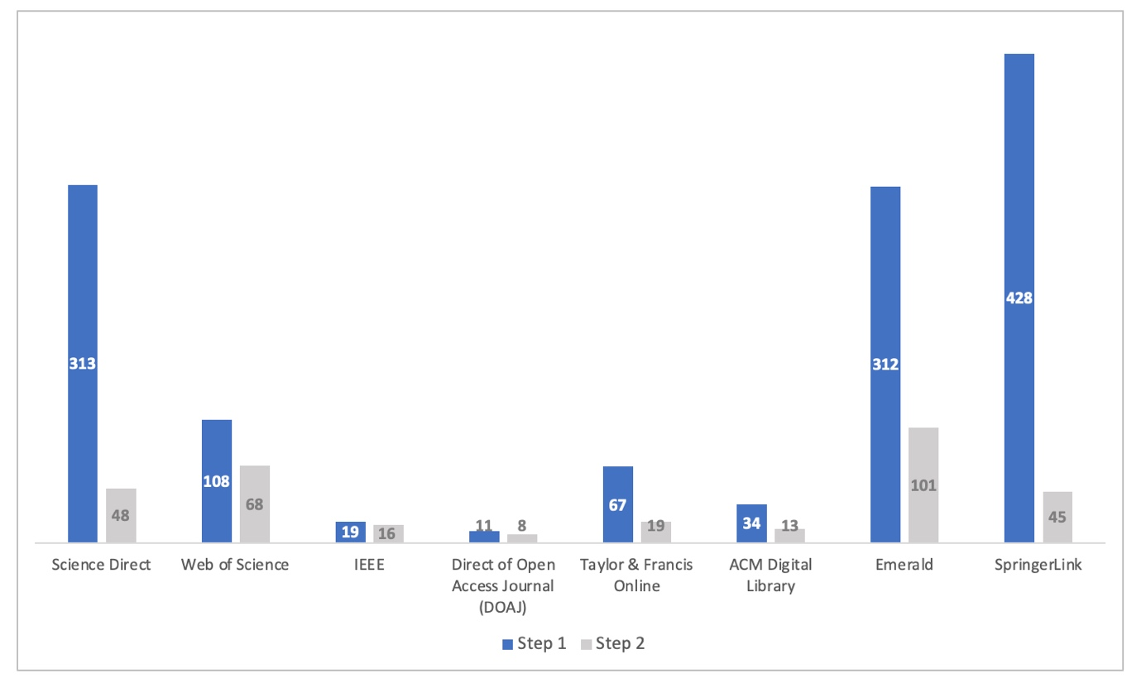
Source: Elaborated by the authors

Figure 2: Number of papers over time
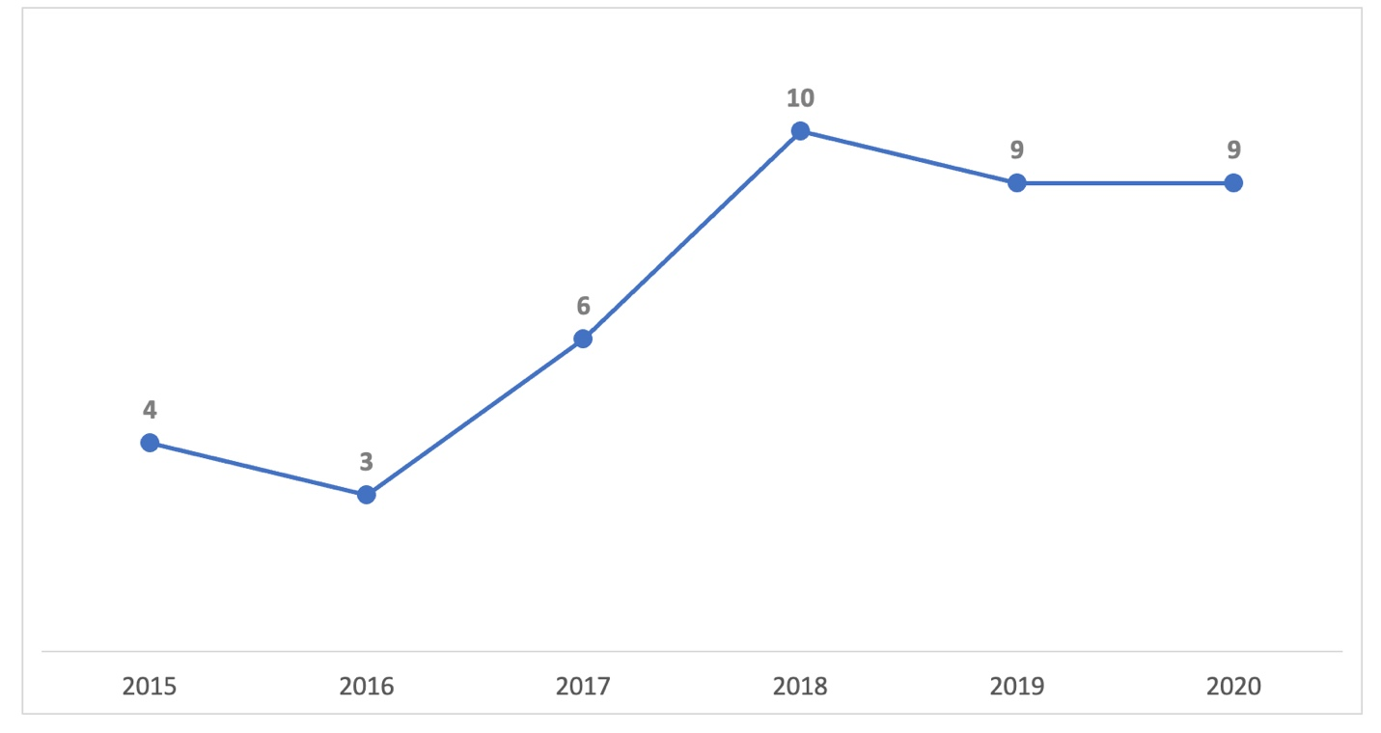
Source: Elaborated by the authors

Figure 3: Percentage of each segment in the selected papers sample
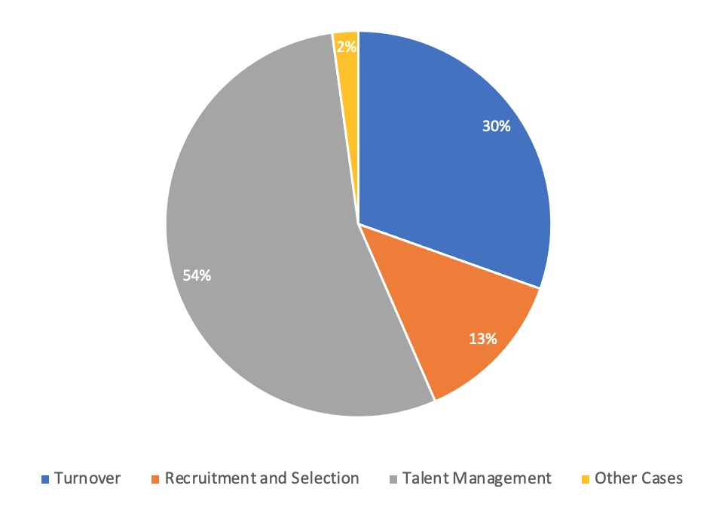
Source: Elaborated by the authors

