**THE USE OF PROJECT PORTFOLIO AND ALIGNMENT MECHANISM WITH THE STRATEGY – A SURVEY WITH BRAZILIAN COMPANIES**

**Theme: Strategic Alignment**

Fernando Santos Dantas, Master in Konwledge Management and IT by Universidade Católica de Brasília (UCB); Administrator with MBA in Project Manager. Actually acts as project and portfolio analyst in the Integrated Modernization Program of Ministério da Fazenda. He is director of the MOLab Company, specialized in education and Project Management. He is a college professor in Centro Universitário - IESB. Email: [ferdantas@gmail.com](mailto:ferdantas@gmail.com)

Tomás Roberto Cotta Orlandi, PhD in Information Science from Universidade de Brasília (UnB), Master in Konwledge Management and information Tecnology from Universidade Católica de Brasília (UCB), Specialist in IT Governance by Universidade de Brasília (UNB), Specialist in Software Engeneering by Universidade Católica de Brasília (UCB). Address: SGAN 916 – Módulo B - W5 Norte - CEP: 70790-160, BSB–DF.Email:[tomasroberto@gmail.com](mailto:tomasroberto@gmail.com)

João Souza Neto, PhD in Electrical Engeneering by Universidade de Brasília (UnB), Master in Electronic Engeneering by the Philips International Institute from Holanda and Professor of the Master in Konwledge Management and Information Technology from Universidade Católica de Brasília (UCB). Address: SGAN 916 – Módulo B - W5 Norte - CEP: 70790-160, BSB–DF. E-mail: [joaon@ucb.br](mailto:joaon@ucb.br)

**SUMMARY**

Currently in Brazil and in the world, the number of organizations that have used the Project Portfolio Management - PPM has increased considerably, as it provides an approach to that points to the coordinated management of the portfolio components (projects, programs, process), aiming to achieve the strategies of organizations. This work aims to perform a quantitative research, regarding the use of Project portfolio as a mechanism of alignment promotion with the strategic management in the Brazilian organizations. Results were compared with those presented by the PMSurvey.org of 2011 and 2012 and identified in the literature the most relevant models of PPM that promote the alignment with strategic management in organizations.

**Key words:** Strategic Alignment, Project Portfolio Management, Project Management, Management Models Project Portfolio.

**1. INTRODUCTION**

According to the Project Management Institute – PMI (2012), in September 2012, there were 390.279 members in 200 countries, as was demonstrated by a survey conducted by PMSurvey.org (2012), showing the growth in demand for Project Management in organizations. Most organizations develop products and services with lower costs, shorter and more quality. However, these same organizations cannot adapt and correctly identify which processes are really strategic (KAPLAN, NORTON, 2004) and which could provide a better organizational performance. Researches point out that the concept of Project Portfolio Management is a recent phenomenon, also superficially discussed with no understanding of its origins, its role and its potential (LEVINE, 1988; COOPER, EDGETT, KLEINSCHMIDT, 2001; KILLEN, HUNT, KLEINSCHMIDT, 2007).

In the academic literature, the term Portfolio comes first in 1952 (MARKOWITZ, 1952), through the Modern Portfolio Theory, gaining prominence from the 90s and 2000, essentially because of the new businesses based on projects.

Currently, the Project Portfolio Management has gained much attention, because organizations are treating their activities and work with projects, programs and portfolios (KILLEN, HUNT, KLEINSCHMIDT, 2007; COSTA, 2012). The Project Portfolio Management refers to the allocation of adequate resources by the organizations and how human resources are allocated, such as budget and which projects should be invested.

Through the PMSurvey.org (2012), it appears that the use of Project Management practices in different sectors of the economy demonstrates that this phenomenon has evolved considerably; in 2003, the 40 companies were participating in the benchmarking study in Project Management in 2012, this number has increased for 730, especially on issues related to Project Portfolio Management.

For Moeckel (2009, p. 102), “the linking of Portfolio Management with the strategy of the organization, is determined by its executives, in order to support the definition of strategic goals and objectives”. According to the PMI (2008a), the Portfolio Management should incorporate these strategic goals and objectives to ensure that the Portfolio components are aligned with the organization’s strategy.

Also according to Moeckel (2009, p. 89):

“[...] the vision and the mission characterize the starting point for the objectives and strategy of the organization are developed. To put into practice this strategy it is necessary to apply processes of strategic management, systems and tools, in order to define and develop the high level in the planning and management operations, in addition to the planning and Project portfolio management. This leads to the implementation of tactical and operation activities related to projects [...]”

There are indications that the Portfolio Project Management is properly coordinated if the implementation of a Strategic Project Office is required (Project Management Office– PMO), in order to align all of the projects of the organization to the organizational strategy (ARCHIBALD, 1992; RIBEIRO, 2007; KRAUSE, 2012). Menezes (2012) says that the Strategic PMO (Project Management Office) is very significant; it promotes alignment between Project portfolio management and organizational strategy through benefits that can be perceived by the organization, such as knowledge and vision, organizational changes and growth.

**2. RELATIONSHIP BETWEEN PORTOFLIO MANAGEMENT, PROGRAMMES AND PROJECTS.**

As PMI (2008a), in mature organizations, Project Management exists in a wider context governed by program management and portfolio management. By mature, Rabechini Júnior (2005) states that many companies reach maturity under the competition and in many cases, this requires time and long periods of adjustments through coordinated actions, so that changes can be implemented properly. Kerzner (2006) argues that the curve of the learning process to maturity is measured in years and the companies committed to use Project Management may be lucky enough to reach maturity in about two years, which doesn’t occur with typical companies, reaching up to five years or more. Also Kerzner (2006) proposes that maturity in Project Management is the development of systems and processes, performed repetitively, what ensure a high probability that each of them becomes a success. These systems and repetitive processes are not in themselves guarantee of success, only corroborate the increased probability. Kerzner (2006) also says that a company may be mature in Project Management and not be great, because the definition of excellence is greater than the definition of maturity. One of the definitions recommended by the PMI (2008a) relating to maturity is the relationship between portfolios, programs and projects. This relationship demonstrates that each one of the terms are different initiatives when it comes to structure and goals, but together exert a greater strategic role within the global organization’s portfolio, which is nothing more than the translation of the goals and strategic objectives (PMI, 2008a).

**THE ROLE OF THE PROJECT OFFICE – PMO**

According to Maximiano (2010), when one distinct organization has a large number of projects to coordinate, it can arise a need to create a unit called Project Management Office PMO. The Project management in Brazil and in the world has experienced a number of changes under the theoretical/conceptual point of view. (RABECHINI JÚNIOR; MAXIMIANO; MARTINS, 2005).

This is evident when we find increasingly, the establishment of PMO in organizations; according to a survey conducted by PMISurvey.org (2011), only 46% of the organizations surveyed reported that they do not have an implemented corporate PMO. Regarding this statement, it's necessary to describe what comes to a PMO.

Ribeiro (2007) contextualizes that the Project Management Offices can take in several names different organizations as “Project Management Office”, “Programs Management Office”, “Programs Office”, “Committee Project Director”, “Project Support Office”, among others; although there is a marked tendency to adopt the term “Project Office”, regardless of the of the power~~s~~ it shows (VALERIANO, 2001; DINSMORE; CAVALIERI, 2005).

According to the PMI (2008a), a PMO is an organizational unit that centralizes and coordinates project management under its rules. A PMO oversees the Projects management, programs or a combination of both. The projects supported or administered by a PMO may not be related other. Some PMOs, however, do coordinate and manage related projects. In many organizations, these projects are indeed grouped or are related based on the way that will be coordinated and managed by the PMO, witch focuses on planning, prioritization, and coordinated execution of projects and subprojects, all linked to the general objectives of business matrix or client.

According to Kerzner (2006), the creation of the PMOs in organizations is important to place the Project Management within organizations. Generally, the specific role of a PMO in organizations is to perform responsibilities in three levels (MAXIMIANO, 2010): “Project Control Office”, “Project Support Office” and “Strategic Project Office”. As this study aims to contribute for the alignment between Project management and the strategic planning through portfolio management, the “Strategic Project Office” becomes important and responsible for filling the missing alignment. Kerzner (2006) states that within this context, the PMO becomes responsible for contextualizing how projects should be repositioned in organizations.

In Brazil, Santos (2007) conducted a study of the positioning possibilities of the PMO on strategic contexts within organizations through a case study. The emphasis of the study focused on the evaluation and difficulties of implementing corporate strategies through projects and the way in which a PMO can contribute in Project Portfolio formation processes, within the strategic planning process and organizations’ budget.

**3. THE STRATEGIC MANAGEMENT**

As defined by Tavares (1991) strategy can be used to plan for the long term. As for (MINTZBERG, AHLSTRAND, LAMPEL, 2010) business strategy can be understood as taking measured and anticipated decisions about what to do and what not to do, when, who and how to achieve predetermined targets in a predefined time. Yet according to Mintzberg, Ahlstrand and Lampel (2010), the word strategy is one of these words that inevitably is defined in a way, but often we use it in another one. That is, the word strategy is a behavior over time. Wright, Kroll and Parnel (2011), corroborate Mintzberg, Ahlstrand and Lampel (2010) towards strict sense of the word, referring to senior management plans to achieve results consistent with the mission and the general objectives of the organization. To Rezende (2002), once known the concept, types, forms of classification and the development processes of the strategies, it is possible to understand the planning, execution and consequences of formulated strategies.

**STRATEGIC ALIGNMENT**

Duque and Pelissari (2010) claim that the project management has been presented as a set of processes able to lead to efficient and effective implementation of organizational strategies. Milosevic and Srivannaboon (2006) and Morris and Jamieson (2004), already note that the strategic alignment comprises several areas in organizations, involving policies, activities, practices and performance. Milosevic and Srivannaboon (2006) note that the project management should also be aligned to the strategy of organizations. Morris and Jamieson (2005) already claim that although there is a consensus among managers and strategists as the need of alignment between the organizational strategy and the projects conceptually, this relationship can’t be clearly established at the operational level. Artto et al. (2008) concluded that the literature assumes that the projects have a tactical role rather than strategic one. Rao (2007) explained that a proper connection between strategy and management projects requires the recognition factors and operational metrics during the formulation of the strategy, and that the implementation of the strategy can be compromised by communication and understanding failures at the operational level.

According to Milosevic and Srivannaboon (2006), if there is no alignment between projects management and organizational strategy, the organization can continue to execute projects that don’t meet their vision, neither contribute to its mission, despising important resources. Artto and Dietrich (2007) explained that the challenge for organizations to align organizational strategy and project management is to encourage participants to use and develop appropriate strategies to the organizational context. The authors emphasized the need to have feedback into the strategic process from coming perceptions of the tactical and operational levels. For Patanakul, Shenhar and Milosevic (2007) in the evolution of the Project management to a strategic approach with an emphasis on organizational perspectives, the project manager must understand the organizational strategy and develop project management based on this strategy. Cabanis-Brewin (2006) identified by survey that the set of best practices provide strategic alignment and can be understood in two ways: governance and processes.

**4. PROPOSED MODELS FOR ALIGNMENT**

Authors like Buys and Stander (2010), argue that one in three initiatives to implement the strategy fails because innovative or project activities are not separated from the daily activities and because the project portfolio management is not aligned with the strategic management of organizations. These authors report that this deployment fails mainly because most of the selected projects have few available resources and priorities constantly change. In contrast, Osama (2006), argues that the performance of research and development related projects are influenced by the alignment of individual initiatives with the strategic management.

Padovani, Carvalho and Muscat (2011, p. 02) argues that:

“The implementation of successful portfolio management isn’t a trivial task, since it encompasses market and technological uncertainties, trading for resources often scarce among different areas of the company, changing due to market turbulences, the adoption and use of suitable criteria for classification, selection, prioritization and sequencing of projects aiming to align the portfolio with the organization’s strategy.”

According to McDonaugh III and Spital (2003), it’s important that organizations undergo a periodic evaluation of the projects that will be paralyzed and have no interest in the organization, reallocating resources to higher value-added projects, as successful factors in project portfolio management.

In order to understand the importance of the project portfolio management, five elements models were chosen based on 97 texts selected from the literature and developed from the 90s by Archer and Ghasemzadeh (1999), Rabechini Júnior (2005), PMI (2008b), Kerzner (2006) and Carvalho and Rabechini Júnior (2007, 2010). Some strategic alignment stages were considered for these analysis, such as: resource definition, classification of projects, individual projects evaluation, selection and prioritization of projects, allocation of resources and control of the projects portfolio.

**The model of Archer and Ghasemzadeh (1999)**

Archer and Ghasemzadeh (1999) explored various methods and portfolio management models and proposed a structure that ranges from the selection of projects proposals.

The project moves into the assessment phase to check if it’s aligned to the strategic development, and if so, the project can be successfully concluded, as has been aligned to the strategic management of the organization, as shown in figure 2.9.

Figure 2.9 – Framework for selecting projects of a portfolio.

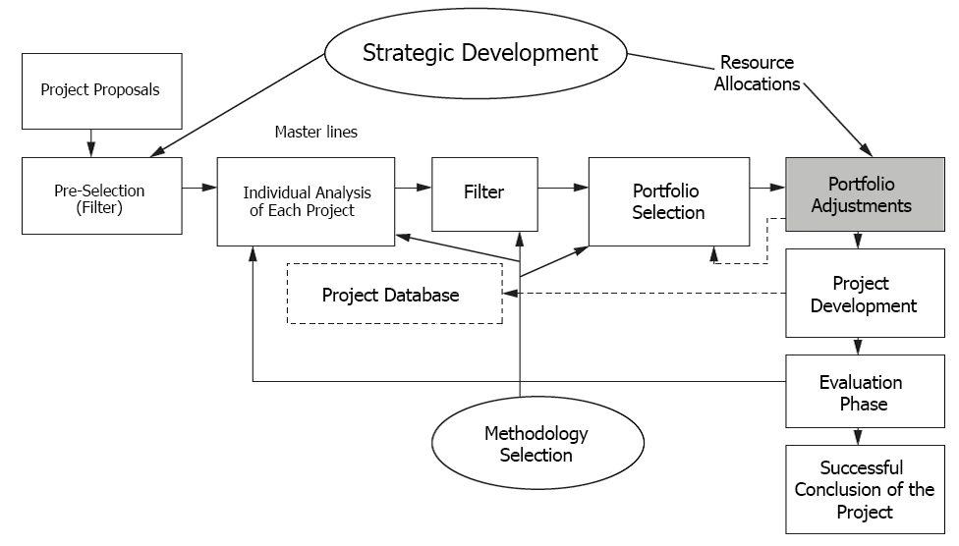

Source: Adapted from Archer and Ghasemzadeh (1999).

**The model of Rabechini Júnior (2005)**

The model Rabechini Junior includes 6 dimensions, as figure 2.10.

Figure 2.10 – Portfolio Management Model for Project.

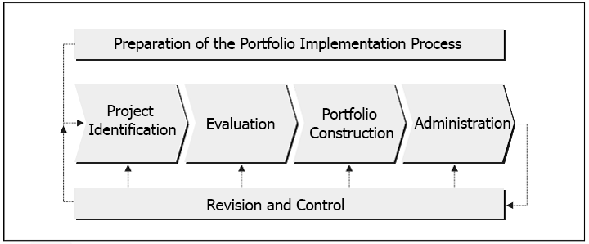

Source: Rabechini Júnior (2005)

a) First Dimension: it refers to the preparation of the implementation process of portfolio management in an organization. This process should include the following elements:

• Identification of evaluate criteria.

• Establishment of weights for these criteria.

The portfolio management should proceed to structure the projects portfolio.

b) Second dimension: identifying must be considered.

This dimension should consider the minimum information about the projects. It’s expected that those interested, here, may have data, as if they were parts of a Project Chart. At the end, a complete list of projects should be developed.

c) Third dimension: the evaluation aims a list of priority projects adding relevant information to these developments. For this, must first provide the realization of evaluation rounds. This dimension suggests the establishment of committees formed to consolidate the filters of an evaluation. The projects that have passed through the filters are candidates to a Project formation.

d) Forth dimension: It aims to establish a portfolio management. The proposed model considers that this dimension should also be preceded by an aggregate plan of Project portfolio. One of the relevant aspects of this dimension is precisely the plan of training and integration of new projects in the portfolio, once they begin to dispute resources from then.

e) Fifth dimension: it refers to the portfolio administration. In this dimension, some elements were possible to point out: the control of resources of various projects in progress, monitoring the life cycle, Project to project, the costs, the financial schedules and the portfolio quality. In this dimension, it is expected that the stakeholders can manage the skills of human resources for capacity building, training and coaching, as the success of the portfolio depends on their performances.

f) Sixth dimension: review and control, since the portfolio being developed needs to be accompanied. For this, it’s expected that the portfolio manager is responsible to propose the follow-up meetings with project managers. The portfolio manager will make decisions amending the constitution of the project portfolio.

**The PMI model (2008b)**

The Standard for Portfolio Managementpattern (PMI, 2008b), was conceived by PMI based on the need of organizations to align project management to organizational strategy, as the PMBOK (PMI, 2008a) doesn’t address these issues’ ink. However, even if The Standard for Portfolio Management can help organizations to align the projects to strategic management, brazilian organizations are still unaware of it. Currently, some studies point out to the theme that deals with strategic alignment, determining that the successful implementation of portfolio management can be seen in alignment between Project management and strategic planning. (DYE, PENNYPACHER, 1999). There are business challenges in the implementation of project portfolio management, that make some fundamental concepts and which can be applied to individuals in organizations. Among them, the possibility of project managers has autonomy to participate in strategic decisions in organizations. (TERRA *et al.,* 2012).

Already, according to Rabechini Júnior, Carvalho and Laurindo (2002), these challenges are determined through critical factors in the implementation of Project portfolio management. However, few brazilian organizations have developed a suitable model of Project management. In innovative organizations, the communication isn’t transmitted properly. Cleland and Ireland (2002) corroborate with Rabechini Júnior, Carvalho and Laurindo (2002) when they establish that the organizations dealing with constant changes are generally considered innovative by adopting actions which align project execution to the organizational strategy. Rocha and Negreiros (2009), start assuming that even having an adopted strategy for the management of each project, if the alignment occurs, there will be a more cohesive and balanced management, increasing the chances of success on selecting the suitable projects for strategic management. Thus, portfolio management will be the link with organizational strategy. This model makes interconnection with strategic management, feeding the strategic goals and objectives.

Figure 2.11 – Portfolio Management Processes for Project

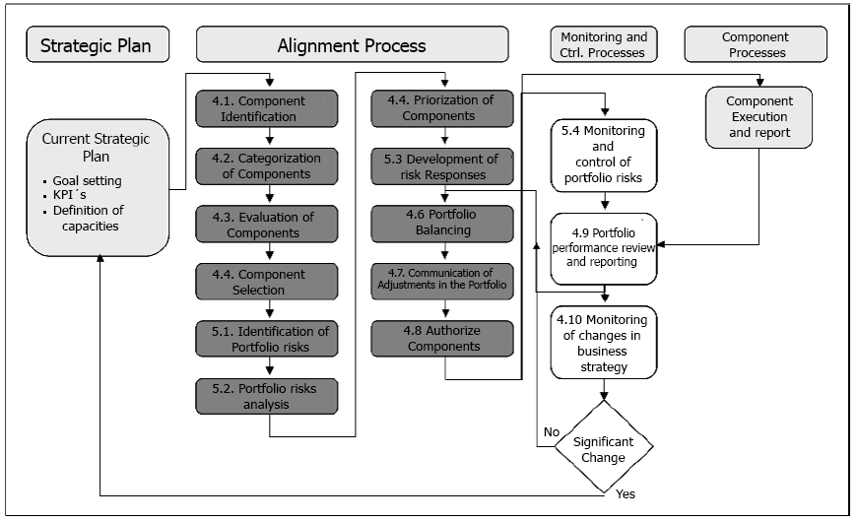

Source: PMI (2008b)

**The Pro-value model of Carvalho and Rabechini Júnior, (2010, 2007)**

The Pro-value model proposed by Carvalho and Rabechini Júnior (2010. 2007) involves six chain links, which receive inputs from the strategic layer and whose outputs feeds the multi-project management, which is the ongoing Project portfolio management: Preparation, Enabling Proposal and Projects, Selection and Prioritization, resource allocation, balancing and adjustments and portfolio combination. According to Carvalho and Rabechini (2011), the strategic layer on top provides the project portfolio layer with the entries of strategic planning , detailing the strategic guidelines, the future vision panels in terms of technology and market, the prioritization criteria and the available resources to the decision-round of the projects portfolio. The outputs of Project portfolio management will feed the management layer that is borned by the PMO and managers responsible for the ongoing projects. The flow of a/the multiproject layer, as reported by the authors, is essential for the project portfolio evaluation, because it feeds the ongoing projects’ feedback through performance reports.

Figure 2.12 – Portfolio Management – Pro-value Model

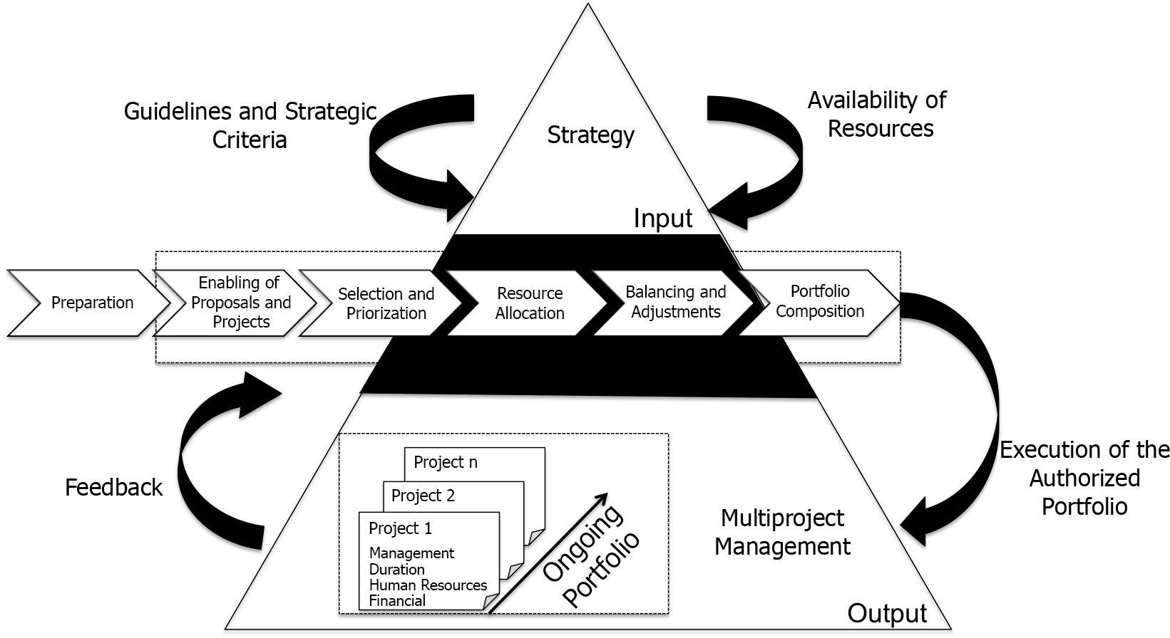

Source: adapted from Carvalho and Rabechini Júnior (2007, 2010)

Carvalho and Rabechini Júnior (2011) also draw attention to the importance of a solid foundation information from ongoing projects, systematized by the PMO or a common area of virtual storage, in order to keep them easy to access the performance reports to managers. The authors recommend that the nature of project portfolio management can be seen considering two significant conceptual elements: strategic adherence and effectiveness, providing the bases for the application and proper alignment with organizational strategy.

**The Kerzner Model (2006)**

Kerzner (2006) also corroborates Archer and Ghasemzadeh (1999) to recognize that senior administration generally has much less information than they want to assess in the possible projects, as many uncertainties that surround the probability of success of one or more projects. This lack of a reliable basis always leads managers to another problem: the lack of a systemic approach to project portfolio (from selection to evaluation). Kerzner (2006) also reports that decisions related to project portfolio management are often mistaken for behavioral and organizational factors and that the loyalty to departments, conflicts, desires, difference in perspectives and unwillingness to share information can harm the selection, approval and evaluation of projects process, due to the many projects being subjective in nature. Kerzner (2006) defends that the overall process of project portfolio management should include four steps.

Figure 2.13 Project Selection Process

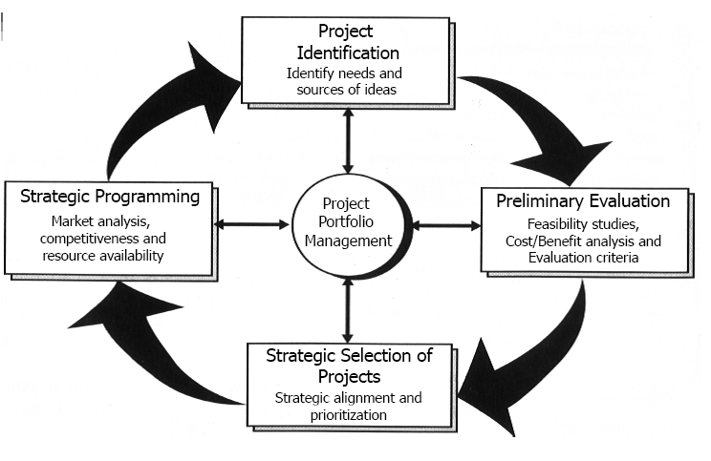

Source: Adapted from Kerzner (2006, p. 248)

**ANALYSIS OF THE PRESENTED MODELS**

The authors explicitly report on how the processes must be addressed for Project portfolio management, shown in Table 1 comparison.

Table 1 – Comparative Table of Portfolio Management Processes

|  |  |
| --- | --- |
|  | **MODELS** |

|  |  |  |  |  |  |  |
| --- | --- | --- | --- | --- | --- | --- |
| **Process** | **Metrics** | **Archer & Ghasemzadeh (1999)** | **Rabechini Júnior (2005)** | **PMI (2008b)** | **“Pró-Valor” Carvalho & Rabechini Júnior, (2007, 2010)** | **Kerzner (2006)** |
| Alignment Process | Projects Identification | x | X | X |  | X |
| Categorization | x |  | x |  | X |
| Evaluation/Preparation | x | X | x | X | X |
| Portfolio Selection/ Construction | x | X | x | X | X |
| Prioritization | x |  | x | X | X |
| Portfolio Balance and Adjust | x |  | x | X | X |
| Adjusts Communication | x |  | x |  |  |
| Authorization | x |  | x |  | X |
| Portfolio  Report and Review | x | X | x |  | X |
| Strategic Changes |  |  | x |  | X |

Source: Own authorship

Give the comparative table of analysis, there is no consensus about which procedures are to be followed to align the project portfolio management to the company’s strategy, although there is the use of several identical processes in the analyzed models.

**5. THE GLOBAL RESEARCH PM SURVEY**

Since 2003, the Rio de Janeiro section of PMI has been realizing a benchmark study with brazilian organizations in order to check which initiatives of project management, programs and project portfolio are being used and which practices are employed. This study used the studies of 2011 and 2012 PMISurvey.org as a parameter of the study’s relevance, more specifically just one of the dimensions related to the project portfolio management. According to PMSurvey.org (2012), the Project portfolio management is dimensioned as an area of research, because it’s a topic of great importance in project management nowadays. In Graph 1 the evolution of the number of participants PMSurvey.org organizations can be observed. In 2003, the study included 60 participating companies; in 2012, this number reached 730 participating companies, an increase of 1.217% in 10 years.

Graph 1- Evolution of the number of participating organizations PMSurvey.org

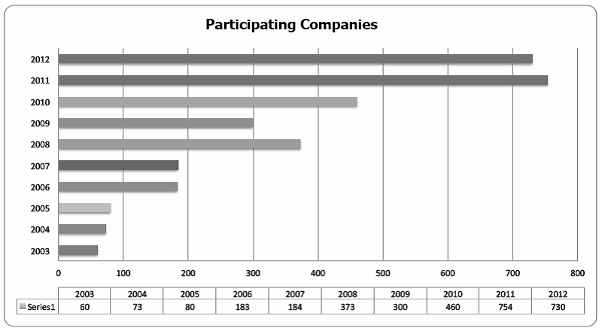

Source: Own authorship

The PMSurvey.org addresses eight important aspects in order to identify the organization’s alignment with the best practices in project management, as follows: organizational culture, organizational structure, project portfolio management, Project Management Office – PMO, processes and methodology, professional development, tools and performance and results. The project portfolio management dimension was solely used for his study. This dimension has eight questions related to the alignment level between portfolio project management and strategy in organization, mentioned below:

• Alignment level between projects and strategy;

• Level of Using of Balanced Scorecard – BSC;

• Level of use of process for election and prioritization of portfolio;

• Level of use of process for monitoring portfolio performance;

• Percentage of projects undertaken in the last year in relation to planned projects;

• Area in Organization responsible for conducting the Project portfolio management processes (selection, prioritization, monitoring);

• Portfolio management practices used by organizations; and

• Level of use the concept of programs in Organizations.

According to PMSurvey.org (2012), this section aims to present how the organizations are managing their project portfolio, with regard to practices, processes, definition of responsibilities and maturity level. Here will be shown a comparison between the years 2011 and 2012, related to the alignment level between projects and strategy in the dimension of project portfolio management.

In PMSurvey.org (2011), the first question to be considered is the alignment level between projects and strategy. In 2011, according to PMSurvey.org:

* 37% of organizations surveyed reported that they are always aligned to strategic planning;
* 49% reported that they not always aligned to the strategic planning;
* 8% reported that there is no alignment, because the strategic planning is not communicated; and
* 7% reported that there is no alignment, because the strategic planning doesn’t exist, as shown in Table 2.

Table 2 – Level of alignment between projects and strategy (2011):

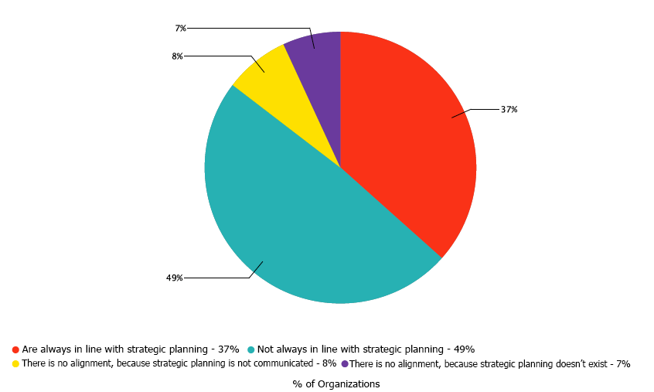

Source: PMSurvey.org(2011)*.*

In 2012, according to PMSurvey.org:

* 39% of organizations surveyed reported that they are always aligned to strategic planning;
* 45% reported that they not always aligned to the strategic planning;
* 8% reported that there is no alignment, because the strategic planning is not communicated; and
* 8% reported that there is no alignment, because the strategic planning doesn’t exist.

Table 3 - Level of alignment between projects and strategy (2012)

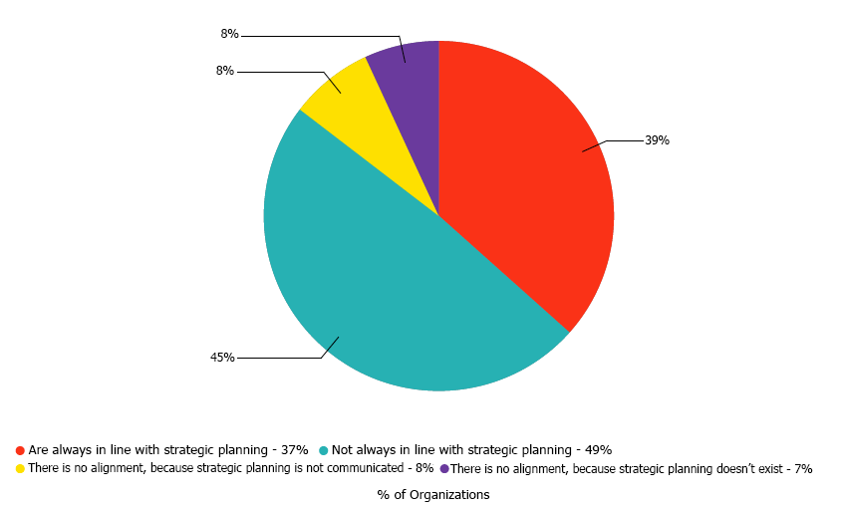

Source: PMSurvey.org (2012)

It’s possible to analyze data between 2011 and 2012, that although there is an increase of two percentage points in the number of organizations aligned with the strategic planning, this number indicates a growing number of organizations concerned with the alignment. However, it’s important to consider that this statement it’s not a reality of all brazilian organizations. This is just a picture of the organizations that participated in the survey, requiring in this case, more subsidies to reach a suitable conclusion.

**Considerations about the years 2011 and 2012**

Through the numbers featured between the years of 2011 and 2012 survey by PMSurvey.org in Brazilian organizations, this study took into account only one dimension of the research, which is related to the Project Portfolio Management. Although the numbers are considered suitable, special attention can be given to the items bellow the items that deserve special attention are:

* 1.3.6 – that is the area in organization responsible for conducting processes of Project Portfolio management (selection, prioritization, monitoring);
* 1.3.7 – that is the practices of portfolio management used by organizations

In these two items, the percentages presented in the survey showed that organizations don’t align to the Project Portfolio management to the strategic management.

Based on this observation, this study becomes relevant, because it demonstrates that lack of resources, financial waste, failure to follow the strategic goals and objectives and failures on ROI, point to the alignment loss between project portfolio management and strategic management of organizations.

**6. A RESEARCH METHODOLOGY**

According to Bagno (2003), a research is a logical sequence that connects the empirical data to the initial research questions of the study, and, ultimately, to its conclusions. The bibliographic survey involved bibliographic revision and sought projects management concepts, portfolio management and strategic alignment, in order to know and characterize the models to be identified. The identification of project portfolio management models already sought to understand what are the common and different characteristics of each model, describing, characterizing and ranking each model.

**Plan Definition and Survey Sample**

According to Creswell (2010), the questionnaire can be defined as a research technique composed by a large number of questions directed to people, to collect opinions, beliefs, feelings, interests, expectations and experienced situations. The objective of this research was to know which models of project portfolio management are used by Brazilian organizations. The selection of the sample specifically focused specialists who work in the organizations surveyed with strategy, project portfolio management and project management. For this research, we used the search website SurveyMonkey ([//pt.surveymonkey.com/s/portfolioeestrategia](http://pt.surveymonkey.com/s/portfolioeestrategia)). The data collection was carried out between the months of May 2013 and June 2013.

**The National Survey in Organizations**

In applied research, we obtained an amount of 56 (fifty-six) respondents and only 1 (one) respondent ignored the process. The questionnaire contained only the company’s name and the respondent’s email to send the search result. There's a large number of public organisations among the 56 (fifty-six) respondentes companies, as follows: 30,36%, the others are: tied with 14,29% companies in the service sector and information technology; also tied with 7,14% consulting and federal agency; with 5,36% de education sector; with 3,57% are tied to the he food sector, industry, financial and other; at lastly, tied with 1,79% the sectors insurance, telecommunications and health. Regarding the number of employees, most 32,14% of respondents have more 5.000 than employees; secondly, the organizations with fewer than 100 employees with 21,43%; thirdly, the organizations with between 101 to 500 employees showed 19,64%; and ultimately the organizations with 501 to 5.000 employees. As for the to the annual revenue, 58,93% of the organizations answered they had revenues in 2012, up from 10 million reais; 21,43% reported that gross less than $1 million; 14,29% reported revenues of between 1 and 5 million Reals; and 5,36% reported sales between 5 to 10 million reals .

The questions were prepared, according to the previous survey in literature, in the following order:

1. Does the organization have a corporate governance structure?

2. Does your organization have a formal process of strategic planning?

3. Does the organization have a defined process for Project management?

4. Is there a formal authorization process of the project?

5. Is there a process to identify all the projects to be implemented?

6. Is there a categorization process of projects?

7. Is there an evaluation process of the projects to be implemented?

8. Is there a selection process of projects to be implemented?

9. Is there a project prioritization process prior to authorization to perform?

10. Is there a monitoring process if the projects are aligned to the organizational strategy?

11. Does your organization have a PMO (Project Management Office)?

12. If your organization has a PMO (Project Management Office) deployed, what kind?

13. The PMO (Project Management Office) constantly monitors the strategic actions implemented?

14. Does the organization have a defined process for Project portfolio management?

15. Is there a portfolio rebalancing process project portoflio and programs?

16. Is there a portfolio performance verification process?

17. Is there a monitoring process to provide subsidies if the Project portfolio is aligned to the organizational strategy?

18. How do you and your organization determine the alignment degree of the Project portfolio with strategic planning?

19. Which model your organization uses to align project portfolio to the organizational strategy?

20. What other factors do you consider important for the proper alignment of the portfolio projects with the organizational strategy?

**7. ANALYSIS OF SURVEY RESULTS**

The issues analyzed by the authors were the most relevant, showing the situation of organizations regarding the use of Project Portfolio as a promotional mechanism of alignment with the strategy. The thirteenth question asked if the PMO constantly monitors the strategic actions implemented in organizations. In this issue 31,11% of organizations answered that the PMO doesn’t monitor the strategic actions; 26,67% reported that PMO monitors just the strategic actions of projects; 24,44% reported that PMO monitors all the strategic actions; and 17,78% reported that PMO monitors some strategic actions. In this issue, we note the role of strategic PMOs isn’t fulfilling one of the functions that is monitoring, not only the strategic actions of projects, but also all strategic actions.

The fifteenth research question asked if there is a portfolio balancing process project and programs. 60% of organizations reported that there is no formal process; 17,78% reported that between 2 to 5 years; 15,56% reported there is more than 5 years; 6,67% reported that between 1 to 2 years; and no organization said that there is less than one year. The seventeenth issue asked whether there is a monitoring process to provide subsidies if the Project portfolio is aligned with the organizational strategy. 60% organizations reported that there is no formal process; 20% reported between 2 to 5 years; 11,11% reported that exists more than 5 years; 6,67% reported that between 1 to 2 years; and 2,22% answered that there is less than one year.

Graphical 4 – Issue 17

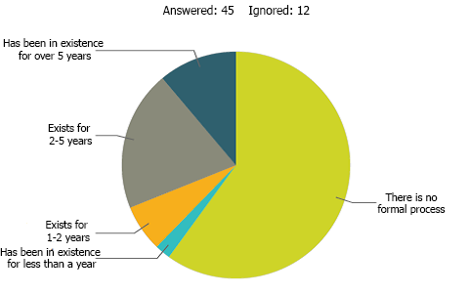

Source: Own authorship

The eighteenth research issue asked how the manager or the organization determine the alignment degree of the project portfolio with the strategic planning. 44,44% of organizations reported that they are always aligned to strategic planning; 28,89% reported that they are not always aligned to the strategic planning; 15,56% reported no alignment because the strategic planning is not reported; and 11,11% reported no alignment because the strategic planning doesn’t exist.

Graphical 5 – Issue 18

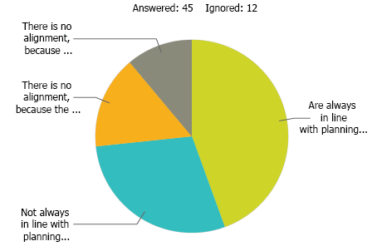

Source: Own authorship

The twentieth issue asked what other factors are considered important for the appropriate alignment between project portfolio and the organizational strategy. 40,91% of organizations responded organizational management as an important factor; 25% answered that organizational culture is an important factor; 20,45% responded to political issues; 6,82% reported as important the organizational values; other 6,82% responded with open answers.

It’s important to set clear the many limitations in the application of the results, since the questionnaire covers a small sample. In no way it reflects the Brazilian organizations., not reflecting Brazilian Organizations at all.

**8. CONCLUSION**

This study sought to identify, through a structured survey, alignment of projects with strategic goals and objectives. The survey data was completed from professionals in the areas of strategic management, projects management and project portfolio management with which the researcher has direct contact through the Project management community in Brazil.

As demonstrated in the survey’s result, these professionals represent companies with more than 100 employees, and the majority have more than 5.000 employees. Most of the respondent organizations are public and all organizations surveyed have a budget of over one million reais.

It was possible to compare this search’s results with the data results shown in the search of PMSurvey.org (2012). According to that, 39% of organizations surveyed reported that they are always aligned to the strategic planning; 45% reported that they are not always aligned to the strategic planning; 8% reported there is no alignment because the strategic planning is not reported; and 8% reported there is no alignment because the strategic planning doesn’t exist. Now, according to this search’s result, it was asked how managers or the organizations determine the alignment degree of the project portfolio with the strategic planning. Here, 44,44% of organizations reported that they are always aligned to strategic planning; 28,89% reported that they are not always aligned to the strategic planning; 15,56% said that there is no alignment because the strategic planning is not reported; and 11,11% reported not alignment because the strategic planning does not exist. The survey also asked if between the models found in the organization, there is uses one which align Project portfolio with organizational strategy. Considering this question, 51,11% reported using none of the models presented in the dissertation; 20% reported using the PMI Model, called The Standart for Portfolio Management; 6,67% reported using the Kerzner Model (2006). No organization reported the use of the models of Archer and Ghasemzadeh (1999), Rabechini Júnior (2005) and the Pro-value model of Carvalho and Rabechini Júnior (2007, 2010). Among the respondents, 8, 88% reported not knowing which model the organization uses; and 3 respondents reported models not raised in the literature. The models informed are: “own model”, “Managing Successful Programs” from OCG (UK) and a model created for the Competitive Brazil Management (MBC) with the assistance of the National Management Development Institute (INDG).

Finally, the survey asked the respondents what other factors are considered relevant for the appropriate alignment between Project portfolio and organizational strategy. In this respect, most organizations answered that organizational management is an important factor and the minority responded as important organizational values.

The results show that most organizations don’t use any alignment model between project portfolio management with organizational strategy. Notice that there is room for expansion of the models presented as a way to align the project portfolio management to organizational strategy.

In this study, the alignment factor of project portfolio management with organizational strategy listed aspects of the 5 models found in literature and submitted to an analysis of focal group. The result of this factor confirms the importance given by the respondents to the alignment of project portfolio management to organizational strategies. The authors recognize that the results presented in this article are limited to the extent of the study.

A further work is suggested on the expansion of the research model in order to analyze other variables not considered in this study, which could contribute significantly to a hybrid model project portfolio management, in order to align the project portfolio management to the strategic management in organizations.

It’s also suggested that further studies are to be made to understand why the strategic managers fail to arrange properly the desirable skills necessary to conduct the alignment between project portfolio management and the organizational strategies.

**9. REFERENCES**

ARCHER, N.; GHASEMZADEH, F. An integrated framework for project portfolio selection. International Journal of Project Management, 17(4), 207–216, 1999.

ARCHIBALD, R. D. Managing high-techonogy programs and project. 2. ed. New York: John Wiley & Sons, 1992.

ARTTO, K A.; DIETRICH, P H. Strategic business management through multiple projects. In: MORRIS, P W. G.; PINTO, Jeffrey K. The Wiley guide to project program & portfolio management. New Jersey: John Wiley & Sons Inc., 2007. Cap 1, p. 1-33.

_______; MARTINSUO, Miia; DIETRICH, Perttu H.; KUJALA, Jaako. Project strategy: strategy types and their contents in innovation projects. International Journal of Managing Projects in Business. v.1, n.1, p.49-70. 2008.

ARTTO, Karlos A.; DIETRICH, Perttu H. Strategic business management through multiple projects. In: MORRIS, Peter W. G.; PINTO, Jeffrey K. The Wiley guide to project program & portfolio management. New Jersey: John Wiley & Sons Inc., 2007.

BAGNO, M. Pesquisa na escola. O que é como se faz. SP: Edições Loyola, 2003.

BUYS, A. J.; STANDER, M. J. Linking Projects to Business Strategy through Project Portfolio Management. South African Journal of Industrial Engineering, v. 21, 2010.

CABANIS-BREWIN, J. Best practices for aligning projects to corporate strategy. In: PROCEEDINGS OF THE PMI RESEARCH CONFERENCE, 2006, Seattle. Proceedings: PMI, 2006. P.1-8.

CARVALHO, M. M.; RABECHINI JÚNIOR. Construindo competências para gerenciar projetos. 2. Ed. São Paulo: Atlas, 2007. 317 p.

_______. Valor em projetos: uma abordagem contingencial. No prelo, 2010.

_______. Fundamentos em gestão de projetos: construindo competências para gerenciar projetos – 3. Ed. – São Paulo: Atlas, 2011.

CLELAND, D. I.; IRELAND, L. R. Gerência de projetos. Rio de Janeiro: Reichmann & Affonso, 2002.

COOPER, R. G.; EDGETT, S. J.; KLEINSCHMIDT, E. J. Best practices for managing R&D portfolios: Research. Technology Management, 20–33, 1999.

_______; EDGETT, S. J.; KLEINSCHMIDT, E. J. New Problems, New Solutions: Making Portfolio Management More Effective. Research and Technology Management, v. 43, n. 2, p. 18-33, 2000.

_______; EDGETT, S. J.; KLEINSCHMIDT, E. J. Porfolio management for new products. Cambridge, Mass. Perseus, 2001.

COSTA, Hélio. Seleção de Portfólio de Projetos. PMO: escritório de projetos, programas e portfólio na prática / André Barcaui, (org.). -- RJ: Brasport, 2012.

CRAWFORD, J. Kent; CABANIS-BREWIN, Jeannette; PENNYPACKER, James S..

Seven steps to strategy execution: integrating portfolio, programs, projects and people for organizational performance. Newtown Square: Center for Business Pratices, 2008. CRESWELL, JOHN W. Projeto de pesquisa: métodos qualitativo, quantitativo e misto; tradução Magda Lopes; 3 ed. – Porto Alegre: Artmed, 2010.

DINSMORE, P. C. et. al.. Projetos brasileiros: casos reais de gerenciamento. Rio de Janeiro: Brasport, 2007.

DINSMORE, P. C; CAVALIERI, A. Como se tornar um profissional em gerenciamento de projetos: livro-base de preparação para certificação PMP – Project Management Professional. Rio de Janeiro: Qualitymark, 2005.

DUQUE, Welton Sthel; PELISSARI, Anderson Soncini. Proposição de modelo entre gerenciamento de projetos e gestão estratégica: alinhamento de Processos para a Realização de Objetivos Organizacionais.34 ENCONTRO DA ANPAD, RJ, 2010.

DYE, L. D.; PENNYPACKER, J. S. Project portfólio management: selecting and prioritizing projects for competitive advantage. West Chester: Center for Business Practices, 1999.

KAPLAN, Robert S.; NORTON, David. Mapas Estratégicos: Balanced Scorecard. 1. Ed. –– São Paulo: Atlas, 2004.

KERZNER, Harold. Project Management Best Practices: Achieving Global Excellence. New Jersey: John Wiley & Sons, 2006.

KILLEN, C.P., HUNT, R.A., KLEINSCHMIDT, E. J. Managing the New Product Development Project Portfolio: a review of the literature and Empirical evidence. In: PICMET, pp. 1864 – 1874, Portland, Oregon, 2007.

KRAUSE, Walter. Governança Corporativa e o PMO. PMO: escritório de projetos, programas e portfólio na prática, André Barcaui,(org.). Rio de Janeiro: Brasport, 2012.

LEVINE, H. A. Project Portfolio Management: A practical guide to selection project selection with business strategy. Project Management Journal, vol. 19(5), pp. 14, 1988.

MARKOWITZ, H. Portfolio Selection. The Jounal of Finance, v. 7, pp. 77-91, 1952.

MAXIMIANO, Antonio Cesar Amaru. Administração de projetos: como transformar ideias em resultados. 4. Ed. – São Paulo: Atlas, 2010.

McDONAUGH III, E. F.; SPITAL, F. Managing Project Portfolios: Not theory but day-to-day management policies and actions will determine the success of a new product development effort, this study shows. Research Technology Management, v. 46, n. 3, p. 40-46, 2003.

MILOSEVIC D. Z.; SRIVANNABOON, S. A theoretical framework for aligning Project management with business strategy. P M Journal, v. 37, n. 3, p. 98-110, 2006.

MINTZBERG, Henry, AHLSTRAND, Bruce, LAMPEL, Joseph. Safári de estratégia: um roteiro pela selva do planejamento estratégico. 2. Ed. – POA: Bookman, 2010.

MOECKEL, Alexandre. Sistematização da gestão de portfólio na fase de planejamento estratégico de produtos. 2009. 219 f. Tese (Doutorado) - Curso de Engenharia Mecânica, Universidade Federal de Santa Catarina, Florianópolis, SC, 2009.

MORRIS, P.; JAMIESON, A. Translating corporate strategy into project strategy: realizing corporate strategy through project management. PMI publications, 2004.

_______. Moving from corporate strategy to project strategy. PM Journal. v.36, n.4, p.5-18. 2005.

OSAMA, A. Multi-Attribute Strategy and Performance Archtectures in R&D - The Case of the Balanced Scorecard. 2006. Pardee RAND Graduate School, 2006.

PADOVANI, M.; CARVALHO, M. M.; MUSCAT, A. R. N. Ajuste e balanceamento do portfólio de projetos: o caso de uma empresa do setor químico. Produção. USP, São Paulo, SP, 2011. Recebido 05/07/2009; Aceito 25/07/2011.

_______;_______;_______. Seleção e alocação de recursos em portfólio de projetos: estudo de caso no setor químico. Gestão & Produção, v.17, n. 1, p. 157-180, 2010. Disponível:http://dx.doi.org/10.1590/S0104-530X2010000100013.Acesso em: 10/09/12

PATANAKUL, P; SHENHAR, A J.; MILOSEVIC, D. Why different projects need different strategies. In: SHENHAR, Aaron J.; MILOSEVIC, Dragan; DVIR, Dov. THAMHAIN, Hans. Linking project management to business strategy. Newton Square: Project Management Institute Publications, 2007. Cap. 8, p. 143-160.

PROJECT MANAGEMENT INSTITUTE. **The Guide to the Project Management Body of Knowledge**, **Newtown Square** 4. ed. Pennsylvania: PMI Inc., 2008a.

PROJECT MANAGEMENT INSTITUTE. **The Standart for Portfolio Management**, **Newtown Square** 2. ed. Pennsylvania: PMI Inc., 2008b.

PMSURVEY.ORG. **Project Management Office (PMO) – Um Panorama da Próxima Geração.** 2012.

RABECHINI JÚNIOR, Roque. **Competências e maturidade em gestão de projetos**: uma perspectiva estruturada. São Paulo: Annablume; Fapesp, 2005.

_______; PESSÔA, M S P. Um modelo estruturado de competências e maturidade em gerenciamento de projetos. **Revista Produção**, São Paulo, v. 15, n. 1, p.34-43, 2005.

_______; MAXIMIANO, A C A; MARTINS, V A. A adoção de gerenciamento de portfólio com uma alternativa gerencial: o caso de uma empresa prestadora de serviço de interconexão eletrônica. **Revista Produção**, São Paulo, v. 15, n. 3, p. 416-433, 2005.

_______; CARVALHO, Marly Monteiro; LAURINDO, Fernando José Barbin. **Fatores críticos para implementação de gerenciamento por projetos**: o caso de uma organização de pesquisa. Revista Produção, São Paulo, v. 12, n. 2, p. 28-41, 2002.

RABECHINI Jr.; R. R., CARVALHO, M. M.; LAURINDO, F. J. **Fatores críticos para implementação de gerenciamento por projetos**: O caso de uma organização de pesquisa. Revista Produção, 2002.

RAO, Raju. Connecting organization strategy to projects: the missing link. In: 2007 PMI GLOBAL CONGRESS PROCEDINGS, 2007, Hong Kong. Paper. Newtown Square: Project Management Institute, 2007.

REZENDE, D. A. **Alinhamento do planejamento estratégico da tecnologia da informação ao planejamento empresarial**: proposta de um modelo e verificação da prática em grandes empresas brasileiras. 278 f. Tese (Doutorado em Engenharia de Produção) – UFSC – Engenharia de Produção, 2002.

RIBEIRO, W L. **Proposta de um modelo para a implantação de um escritório de projetos estratégico de TI em empresas de telecomunicações**. Dissertação (Mestrado) – Mestrado - Gestão do Conhecimento e da TI, UCB, Brasília, DF, 2007.

ROCHA, M H Pereira da; NEGREIROS, Luis Alberto de. Alinhamento estratégico e o gerenciamento de portfólio de projetos nas organizações. V Congresso Nacional de Excelência em Gestão. Gestão do Conhecimento para a Sustentabilidade. Niterói, 2009.

SANTOS, Maurício Coletto dos. **O escritório de gerenciamento de projetos no planejamento estratégico e orçamentário:** um estudo de caso na indústria de mídia sob o enfoque da cibernética. 2007. Dissertação (Mestrado) - Curso de Engenharia Naval e Oceânica, Escola Politécnica de São Paulo; USP, São Paulo, 2007.

SHENHAR, J. Aaron; *et al.*. **Linking Project Management to Business Strategy**. Newton Square, PA, US: Project Management Institute, 2007. (19-55).

SHENHAR, Aaron; STEFANOVIC, Joca. Does strategic alignment contribute to business success Project success: a multidimensional strategic concept? In: SHENHAR, AJ.; MILOSEVIC, D; DVIR, D. THAMHAIN, H. **Linking project management to business strategy**. Newton Square: PMI Publications, 2007. Cap. 12, p. 213-232.

SRIVANNABOON, S. Linking Project Managemente With Business Strategy. **Project Management Jounal**, p. 88-96, Pennsylvania, 2006.

TAVARES, M. C. **Planejamento Estratégico**: a opção entre o sucesso e o fracasso empresarial. São Paulo: Harbra, 1991.

TERRA, J C; *et al.*. **Gestão de Portfólio**: o desafio do alinhamento estratégico. Biblioteca: Terra Fórum Consultores. Disponível em: <biblioteca.terraforum.com.br/BibliotecaArtigo/GestaoDePortfolio.pdf>Acesso:02/03/12.

VALERIANO, D. L. **Gerenciamento estratégico e administração por projetos**. São Paulo: Makron Books, 2001.

WRIGHT, Peter L., KROLL, Mark J., PARNELL, John. **Administração estratégica**: conceitos: tradução Celson A. Rimoli, Lenita R. Esteves. 1. Ed. – 12. Reimpr. – São Paulo: Atlas, 2011.