FIGURES

Proposal

Designing the scope of the project
Designing the Project
Non standard terms or conditions
Resource allocation
Cost/Budget Allocation
Personnel Acquisition and Placement
Communication Plan and Efficiency Report
Risk Management
Implementation

Implementation of the design plan
Document, file and output management
General modification of the control process
Preview of quality and control
Final efficiency Review
Contract

Finalization of designed process

Completion

Administrative Closure
Contract Closure
Promotion and Preparation Steps

Figure 1: MAI methodology stages

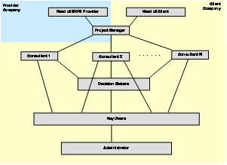

Figure 2: Organisation chart
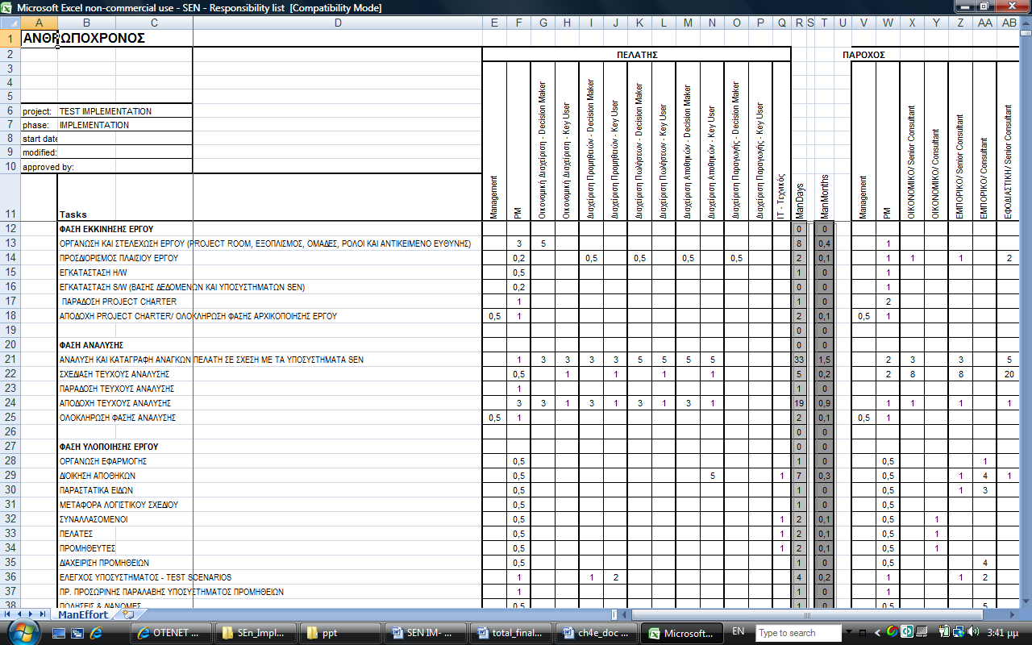

Figure 3: Resource Allocation Report

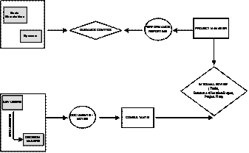

Figure 4: Communication diagram

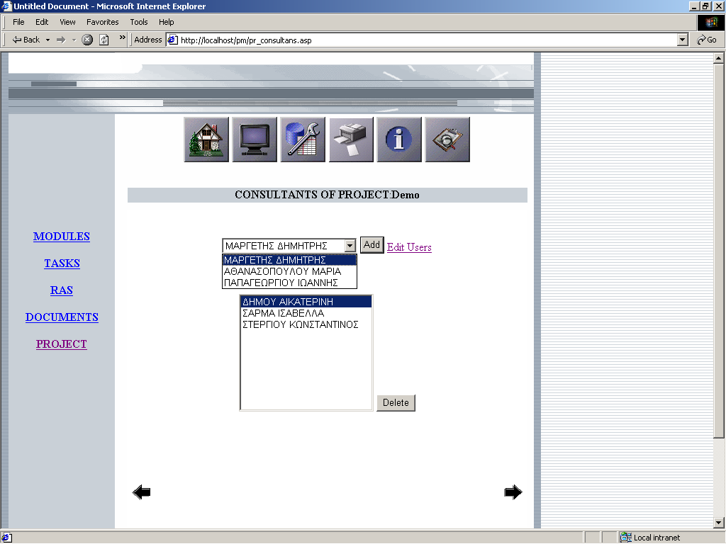

Figure 5: Screen of adding consultants in the project
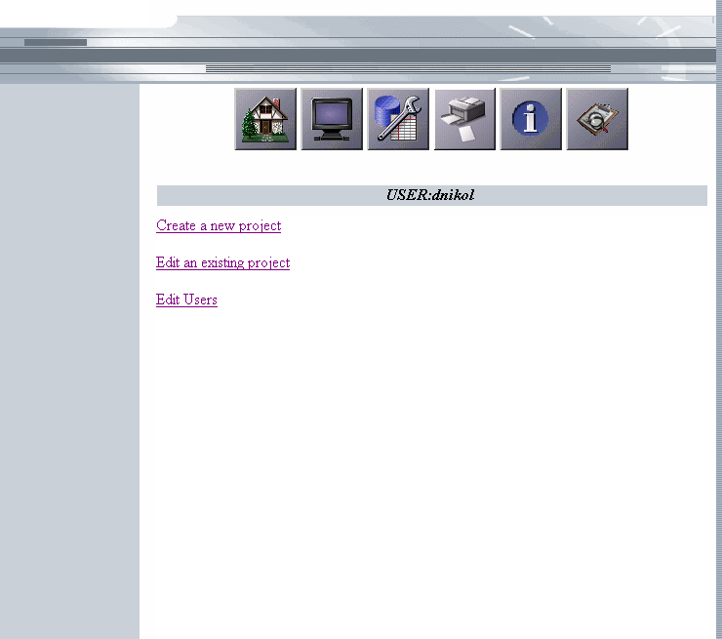

Figure 6: Screen of actions available to user
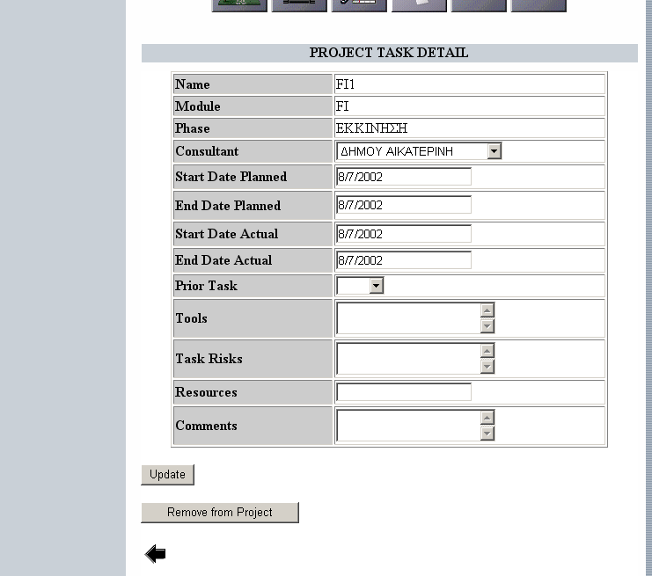

Figure 7: Screen of project task detail

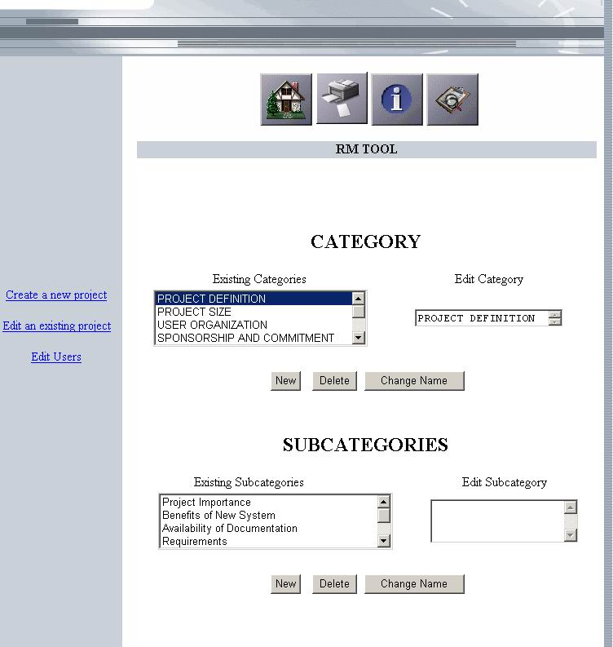

Figure 8: Screen of editing categories and subcategories

